Lab 4, Station 1 6 July 2007

SMS 598: Application of Remote and In-situ Ocean Optical Measurements to Ocean Biogeochemistry

Station 1: standard chlorophyll a in vitro fluorometric measurement
Instructor: Mike Sauer
Location: in MJP main lab
Focus: replication – within a single student’s measurement and
among measurements for all students sampling at the same time

Laboratory Safety Issues – acetone, 10% HCl; see MSDS sheets. Wear goggles and gloves when handling solvents and acids. Open solvent containers only under the hood. Pour all wastes into appropriate containers, including seawater. General laboratory safety practices apply.

Goals – please learn about:
importance of sampling/subsampling – swirl 3X, reverse, swirl 1X, pour
methodology for measurement of chlorophyll a and phaeopigments
extraction – sonication and 24-h in cold, dark to avoid photobleaching
potential interference from chlorophyll b
calibration with pure chlorophyll a standard
use of secondary standard and record keeping
– secondary standard and room temperature

Background:
The basic principle of fluorometry is:

F = E(λ) . conc . Φ_{f}

Where F is fluorescence, E(λ) is the spectral energy of the excitation light, conc is concentration, and Φ_{f} is the quantum yield of fluorescence. N.B.: Φ_{f} decreases as temperature increases; hence, fluorescence should be measured at a constant temperature. For 90% acetone, the temperature coefficient is –0.3% per degree C.

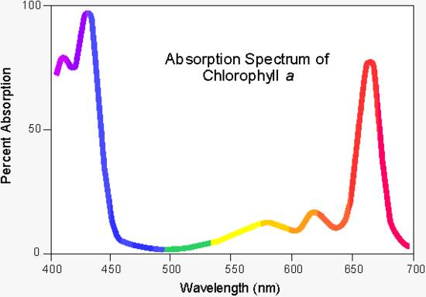
Chlorophyll a absorbs in both blue (Soret) and red (Q) bands (figure; <http://www.ch.ic.ac.uk/local/projects/steer/chloro.htm>).
Chlorophyll a has the additional characteristic of fluorescence, a phenomenon by which a fraction of the photons are re-emitted (for chlorophyll, the fluorescence maximum is at 682 nm in whole cells and 676 nm in acetone extracts (verify wavelengths at Station 2). Photons either directly absorbed by chlorophyll a itself or transferred to chlorophyll a from a photosynthetic accessory pigment (the latter occurs only in the whole cell or in fragments of photosynthetic lamellae), can be re-emitted as red fluorescent photons (verify this statement at Station 2). The fraction of photons emitted/photons absorbed is the quantum yield of fluorescence, Φ_{f}. For chlorophyll a in a solvent extract, Φ_{f} is approximately 0.33; for live cells, Φ_{f} varies between 0.005 to 0.03. Chlorophyll b fluoresces only in vitro (such as in solvent extracts) and not in whole cells.

The standard method for fluorometric analysis of chlorophyll in 90% acetone uses a broad-band blue filter to excite chlorophyll fluorescence and a red filter with a red-sensitive detector to detect fluorescence. However, in field samples both chlorophyll a and its principle degradation products (pheophytin a and pheophorbide a) will also be present. The position of the red absorption peaks is similar for chlorophyll a and its degradation products; however, the Soret peak at 440 nm is not present in the degradation products, rather the blue absorption peak is shifted to 412 nm.

In addition, chlorophyll b may be present in field samples and it also fluoresces in acetone. A major, and too often ignored, problem with the standard filter set is interference from chlorophyll b; this pigment can be present in significant concentrations in some waters masses. The standard filter set is not optimized for excitation of chlorophyll b. However, when chlorophyll b is acidified, pheophytin b is formed and the peak is shifted to the blue; unfortunately, the standard filter set is efficient in exciting pheophytin b. The consequence (see equations below) is that chlorophyll a concentration is underestimated and pheophytin a is overestimated. The Welschmeyer (1994) method avoids the interference of chlorophyll b by using narrow band interference filters that excite only chlorophyll a (436nm) and detect its emission (680nm). This method, however, is not optimized to measure pheopigment concentration; the preferred method for quantitative measurement of all pigments is by HPLC.

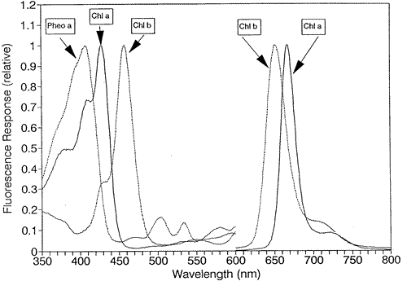

Turner Designs web site has some wonderful technical notes, but not the easiest navigation: <http://www.turnerdesigns.com>.

Fluorescence measurement and computation:
By measuring the fluorescence of an extract before (mixture of chlorophyll a and its degradation product; Fo) and after acidification (only degradation products because chlorophyll a is converted to pheophytin by acid; Fa), the concentration of both chlorophyll and pheopigment can be determine. The method and equations were developed by Yentsch and Menzel (1963) and Holm-Hansen et al. (1965). This basic method can be found as EPA Method 445.0 (Collins and Arar, 1997) and in the JGOFS (1994) protocols; see also the Turner Designs web site (listed in the References). The equations are given below and in the Excel spread sheet in the chlorophyll lab folder <chl_10AU.xls>:

chl a = K (Fm/ Fm-1) x (Fo - Fa) x (v/V) (1)

pheo a = K (Fm/ Fm-1) x [(Fm x Fa - Fo)] x (v/V) (2)

where:
K = calibration coefficient
Fm = max acid ratio Fo/Fa of pure chlorophyll a standard; the ratio is typically around 2 but is fluorometer specific and depends on the combined spectrum of lamp + excitation filter
Fo = fluorescence before acidification
Fa = fluorescence after acidification
v = 90% acetone extract volume (L)
V = volume filtered (L)
Assuming no chlorophyll b, there are two equations, two measurements (Fo and Fa), and two unknowns (chlorophyll a and pheopigment a). Units are mg pigment m⁻³ or μg pigment L⁻¹.

Protocol
- Sampling: each student in the group will simultaneously sample water from the Damariscotta River Estuary with a 1-L bottle. Sample off the dock as close as possible to the same location (for testing of operator replication and true replication). Rinse the bottle three times, and then fill to top. Return immediately to the lab to process samples as quickly as possible.
- Locate three tubes with 5-mL 90% acetone. Note tube labeling system.
- Center a G/FF filter on each filter unit; test that the filter cup is secure.
- Mix sample bottle each time you subsample – swirl bottle three times in one direction, reverse and swirl once in opposite direction; invert bottle and repeat. IMMEDIATELY, pour 200 mL subsample into the graduate cylinder.
- Turn on vacuum; keep below 5 mm pressure. When all water has been filtered, IMMEDIATELY remove filter.
- Wear goggles and gloves to protect from acetone. Place filter in tube with acetone and make sure that filter is completely submerged in the acetone. Secure cap on tube. Record tube ID.
- Keep tube in dim light until you are finished (chlorophyll in acetone bleaches very rapidly).
- Store tubes in freezer for 24-hours to allow chlorophyll to extract from cells into acetone. (Alternatively, you can sonicate the tubes with high frequency sound for 7 minutes; do in ice bath to avoid heating. Allow tubes to extract for 15 minutes in cold and dark. Process as below.)
- To read samples, work in dim light. Turn on Turner 10AU to warm up. Remove tubes from freezer and vortex mix to complete extraction and to ensure uniform distribution in tube. With spatula, push filter to bottom of tube. Wipe finger prints off tube
- Centrifuge for 5 minutes.
- Note and record room temperature.
- Measure and record reading of secondary standard.
- Carefully remove tube from centrifuge; DON’T re-suspend filter pad particles. By now the tubes should be warmed to room temperature.
- Insert tube in fluorometer and read Fo.
- Remove tube, add one drop HCl, read Fa. Wear goggles and gloves to protect from acetone and HCl.
- When finished with all readings, clean up. Turn off fluorometer if no one else will use it. Turn on fan in hood (in chemical lab). Work in hood and empty tubes into 90% acetone waste container. Wear goggles and gloves to protect from acetone. With forceps, remove filter pad from bottom of tube and put in beaker to evaporate. Place empty tubes in special rack for washing. Leave fan on and leave tubes in hood.

Assignment
- Calculate chlorophyll and pheopigment concentration using the Excel spread sheet in the chlorophyll lab folder <chl_10AU.xls>.
- Determine SD for your own samples and for all samples in your group.
- Apply chlorophyll values to assignments in other Stations, as directed.

References
Collins, G.B., and E.J. Arar. 1997. EPA Method 445.0. In Vitro Determination of Chlorophyll a and Pheophytin a in Marine and Freshwater Algae by Fluorescence. Revision 1.2, September 1997. U.S. Environmental Protection Agency, Cincinnati. 22 pp.
JGOFS. June 1994. Chapter 14. Measurement of Chlorophyll a and Phaeopigments by Fluorometric Analysis. JGOFS Protocols. 5 pp.
Holm-Hansen, O., C.J. Lorenzen, R.W. Holmes, and J.D. Strickland. 1965. Fluorometric determination of chlorophyll. J. Cons. Cons. Int. Explor. Mer 30: 3-15.
Jeffrey, S.W., R.R.C. Mantoura, and S.W. Wright. 1997. Phytoplantkon pigments in oceanography. UNESCO Publishing. 661 pp.
Turner Designs – <http://turnerdesigns.com/t2/doc/appnotes/998_5101.html>
Welschmeyer, N.A. 1994. Fluorometric analysis of chlorophyll a in the presence of chlorophyll band pheopigments. Limnology and Oceanography 39: 1985-1992.
Yentsch, C.S. and D.W. Menzel. 1963. A method for the determination of phytoplankton chlorophyll and pheophytin by fluorescence. Deep-Sea Res. 10: 221-231.

