Lab 4, Station 4 6 July 2007

SMS 598: Application of Remote and In-situ Ocean Optical Measurements to Ocean Biogeochemistry

Station 4: Variable fluorescenc, Fv/Fm
Instructor: Andrea Drzewianowski
Location: in MJP main lab
Focus: relationship between variable fluorescence and fluorescence quenching

Laboratory Safety Issues – General laboratory safety practices apply

Background:
What is Variable Fluorescence?
Variable fluorescence is used as an estimate of photochemical efficiency of Photosystem II (PSII). Variable fluorescence, Fv, is the difference between the maximal fluorescence produced when all PSII reaction centers are closed (Fm) and the initial fluorescence when all PSII reaction centers are open (Fo). Fv/Fm is variable fluorescence normalized to the maximal fluorescence:

Fv/Fm= (Fm-Fo)/Fm

The FIRe (Fluorescence Induction Relaxation Fluorometer) is used to measure variable fluorescence (Fv/Fm) by using an induction relaxation curve (see Figure 1). FIRe measures the induction and relaxation of chlorophyll fluorescence on very short time scales (micro and milliseconds) from which Fo and Fm can be measured.

The following summary of the FIRe measurement protocol was taken from the Satlantic FIRe Operation Manual:
The FIRe measurement protocol consists of the following four phases (See Figure 1):
- A strong short light pulse of 80 μs duration (called Single Turnover Flash, STF) is applied to cumulatively saturate PSII and measure the fluorescence induction from Fo toFm (STF).
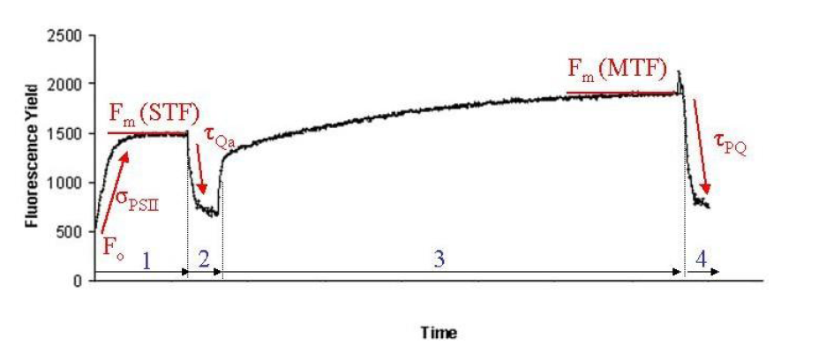

Figure 1. Fluorescence induction relaxation curve.
2. A weak modulated light is applied to record the relaxation kinetics of fluorescence yield on the time scale of 500 ms.
3. A strong long light pulse of ca. 20 ms duration (called Multiple Turnover Flash, MTF) is applied to saturate PSII and the plastoquinone (PQ) pool.
4. A weak modulated light is applied to record the kinetics of the PQ pool re-oxidation the time scale of 1s.

How variable fluorescence is used
Fv/Fm is used to assess physiological state of phytoplankton. A value of Fv/Fm ~ 0.6 represents healthy cells, while cells under stress such as nutrient limitation or high light can have much lower Fv/Fm values (approaching 0.2). The following figures show day-long time courses of variable fluorescence from Station Papa, an HNLC region of the North Pacific (Figure 2) and Damariscotta River Estuary (DRE, Figure 3). Figure 2 shows an overall low Fv/Fm value due to low iron concentrations and a slight decrease over the day due to light stress while Figure 3 shows the reduction of Fv/Fm due to light stress during the day and (Note the different scales on for PAR).

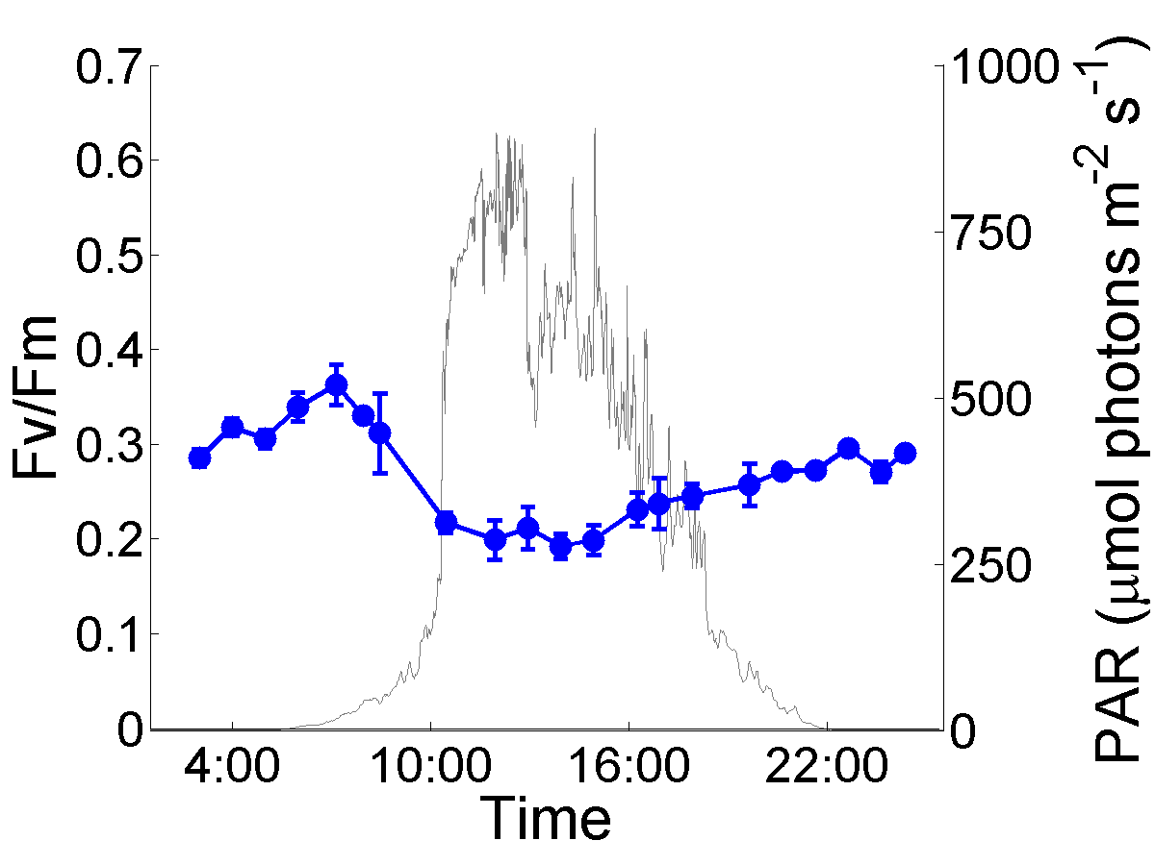
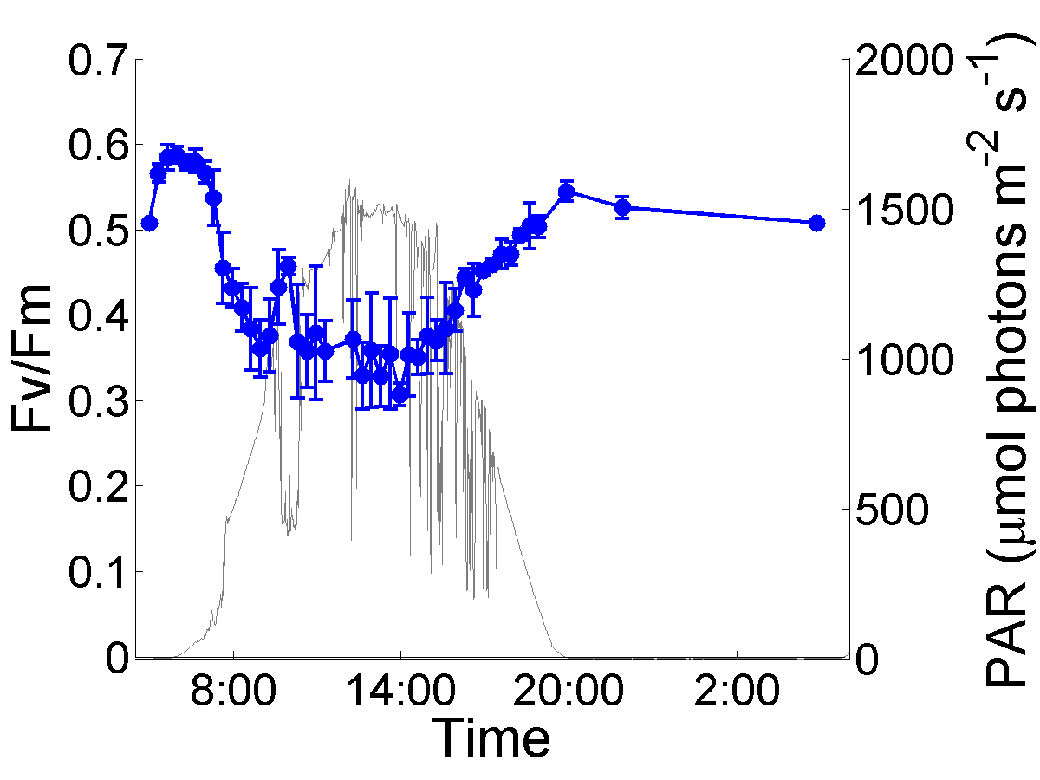
Figure 2. Station Papa Figure 3. DRE

A review of variable fluorescence and photosynthesis can be found in Kromkamp, J.C., and R.M. Forester, 2003, The use of variable fluorescence measurements in aquatic ecosystems: differences between multiple and single turnover measuring protocols and suggested terminology, Eur. J. Phycol. 38: 103 – 112.

Purpose of FIRe Lab:
The purpose of this lab is to familiarize you with the FIRe in preparation for a day-long study of fluorescence quenching of phytoplankton in the Damariscotta River Estuary on Saturday. In today’s lab, every student will have the opportunity to measure and calculate Fv/Fm. On Saturday, Fv/Fv will be sampled hourly from 0400 to 2100.

Sample preparation:
- collect fresh sample from the DRE at the dock and half-fill small ice chest
- place sample in ice chest for 30 minute for dark adaptation
- after 30 minutes, measure take triplicate FIRe readings on fresh subsamples and filtered sea water blank; measure all on the same gain.
FIRe operation:
- Insert USB Thumb drive into USB port on front panel of the FIRe
- Confirm that the Blue toggle switch is in the on position and the green toggle switch is in the off position.
- Turn on FIRe using toggle switch on front panel of the FIRe
- Press enter at prompt to look for USB devices
- Menu Page should come up showing these options (bold are ones that you will use)
  - FIRe View—used to run samples
  - FIRePRo—used to process data
  - FireExec—used to make new excitation profile
  - FIReCont—used for the flow through cells
  - File manager—used to transfer data files to USB
  - Quit
- To run a sample (note: samples should be dark adapted for 30 minutes) enter FIReView program by selecting 1.
  - Notes on using FIReView
    - On right hand side there is a list of commands
      - r-reset —clears window after aborting a sample
      - s-Start/Stop—starts or stops sampling
      - w-write—saves file
      - q-Quit
    - On left hand side there are a series of rounded blue bubbles with different parameters that you can change by using arrows to navigate up, down, left and right. Hit space bar to change the values and hit enter when you finished entering the new value. Here is a list of the parameters you will need to change
      - Exc- This is the excitation profile. A list will be provided with the different excitation profiles to use with different gains. You only change this if you have changed the gain value
      - LogFile- this is where you name the file you are using. You should start with a letter and use no spaces. As you save files the Log File extension will automatically increase by 1(ex from fireexample.000 to fireexample.001). It is easiest when processing your data to use one name for all of your samples and have them differ only in their extensions. You will need to record the file extensions and what each sample is for data analysis purposes.
      - Gain- The gain increases or decreases the sensitivity of the fluorometer and ranges from 0 to 2400 where 2400 is the most sensitive.
      - Del-This is the delay between iterations and should be changed to 2000 to allow the phytoplankton a longer recovery between iterations.
      - N-Acq- This sets the number of iteration for each measurement. For river water set at 30.

  - Determine which gain to use. (For DMC river water start at a Gain of 2000 and adjust up or down from there)
    - Fill cuvette with a water sample
    - Wipe cuvette carefully with KimWipe
    - Place cuevette in cuvette holder and cover with black cuvette cover
    - Press “s” for start/stop
    - The induction relaxation curves should show on the screen. The curves should be between the base of the screen and below the red dashed line. If the sample is above the red dashed line it will not process properly
    - Change the gain value in increments of 200 to get the sample in the middle of the screen.
    - Note: You do not need to run the full 30 iterations but just use the start stop and reset to find the proper gain
    - If the gain changes check the chart to see if the excitation profile needs to be changed

  - To Run a Sample
    - Put fresh sample into the cuvette. Be careful so that you do not expose the sample to light
    - Press “s” to start and allow the sampling to continue until all iterations are done. (An iteration number is displayed on the right side of the screen)
    - Once all iterations are finished Press “w” to save the file
    - Empty cuvette into a saltwater waste beaker and continue to measure different samples

  - To Run a filtered seawater blank
    - Using a Whatman GFF filter filter some of you river sample and save the filtrate.
    - Fill cuvette with filtered water and run on the same gain value as your samples. If you had to change the gain value be sure to run filtered sea water samples for each gain used.
    - Run the same way as regular sample
    - Save measurements (press w)
    - Be sure to record which file extensions apply to the blanks
    - You will subtract the Filtered Sea Water Blank after processing the data in FIRePro.
  - Processing Data
    - Quit from the FIReView program and enter the FIRePro program
    - You move around in FIRePro similar to how you move around in FIReView
    - Enter your first file’s name into the file
    - Press “i” to begin import of the file and to begin processing.
    - FIRePro automatically moves chronologically through the file extension numbers.
    - Note: If the FIRePro program ends before all of the files have been processed restart on the file after it stopped. Ocasionally there are errors and a file can not be fully processed.
    - To get the final processed file open File Manager program in the main menu. Look for the name of your files with the RES extension. This is your processed data file which you can open using excel

