Lab 6 Radiometry and Apparent Optical Properties

Class will divide into two equal groups.

Section 1. PAR Radiometry measurements of the sky and the water off the dock

Activities (Note: perform all activities, process the data as indicated, and answer all questions):
- Curt has emphasized that all we need to measure is the radiance distribution. In this lab we will measure the radiance distribution of sky using a cosine PAR sensor and a Gershun Tube. Using the Gershun Tube and the protractor, divide the sky into azimuthal angles, where φ = 0 is defined as the solar azimuthal angle, and θ is the solar zenith angle.
φ = 0º
φ = 90º
φ = 180º
φ = 270º

θ

Plan View Nadir View (φ = 0º)

Collect Observations for the suite of angles θ = 0 º, 30 º, 45 º, 60 º, 90º and φ  =  0 º, 45 º, 90 º, 135 º, 270 º, 315º. (This represents a total of 30 measurements!)
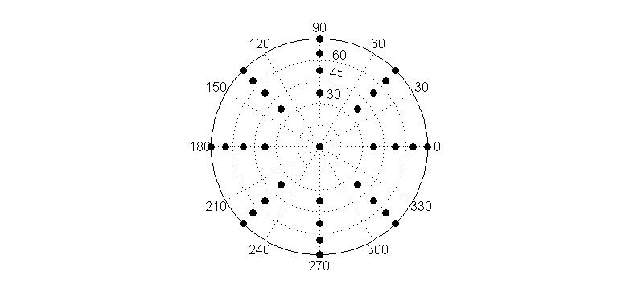
Construct a contour a polar plot of radiance on the graph below.

- Before you plot your data. Describe your expectation of the sky radiance distribution.
- What is the reality of the sky radiance distribution?
- Comment on the practical aspects of measuring the sky radiance distribution. What other considerations would have to be made for making depth profiles of spectral radiance distribution in the ocean.

- Measure the downward scalar PAR and the downward cosine PAR of the incident irradiance. Compute the average cosine of the downward irradiance.
  - Is the average cosine that you computed equal to the cosine of the solar angle? Why or why not?

- Down on the dock deploy the scalar and cosine PAR sensors off the dock ensuring that you have minimized shading by the dock. Place the surface cosine sensor away from any shadowing effects. Collect observations at 0⁺, 0⁻, 0.1m, 0.5m, 1m, 2m, 3m.
  - Correct the in water sensor observations for variations in incoming downward PAR irradiance.
  - What is the impact on E_{d} and E_{od} as you pass through the air/water interface? What do you think should happen, what actually happens, what is your explanation? Afterwards, read the file EnergyConservation.pdf from Curt on the web.
  - Plot the depth profiles of E_{d} and E_{od}. How are they related as a function of depth? Compute the average downward cosine as a function of depth, plot it as a function of depth. How does $\overline{μ_{d}}$vary with depth and what does it tell you about the angular distribution of the light field?
  - Compute the water column average diffuse attenuation coefficients for E_{d} and E_{od} using the exponential fit to the data points.
  - Compute the depth-dependent diffuse attenuation coefficients for E_{d} and E_{od} using the equation: $K_{x}(z) = \frac{−1}{z} \frac{{\text{dE}}_{x}}{\text{dz}}$ where the subscript x = d or od. Plot K_{d} and K_{od} as a function of depth. Indicate the water column averaged values that you computed in part d on the graph. Discuss the differences between the water column averaged values and the depth dependent values, and the differences between downward and downward scalar diffuse attenuation coefficients.
  - The euphotic depth is commonly taken as the depth of the 1% PAR level. Compute this depth. Is the bottom of the river within the euphotic depth by your calculation? What is the light level at the euphotic depth? Compare the light level of the euphotic depth on a sunny day with that on a cloudy day; what matters most to a phytoplankter?
  - Compute the depth of the 17% light level for comparison with the secci depth How does the secci depth compare with the depth of the 17% light level? Does it matter which secci disk you used? Does it matter who used the secci? Read Zaneveld and Pegau (2002) for an alternative use of the secci disk.

Section 2. Spectral Radiometry measurements in the ocean (a.k.a. Damariscotta River). You will be collecting surface and depth profiles of spectral downward irradiance and upward radiance. Your TAs will collect profiles of IOPs at the same time. As part of this lab you will compute the AOPs from your radiometric observations and will answer questions about those AOPs. These will be used to compare with Hydrolight output generated with the IOP profiles so do a good job on your AOPs!

1. Deploy the Satlantic HyperPro in surface reflectance mode to measure E_{d}(0⁺,λ) and L_{u}(~0,λ⁻).
- Compute the median radiance reflectance spectrum and the standard deviation reflectance spectrum,
- Plot the radiance reflectance spectrum including the standard deviation at each wavelength.
- Comment on the magnitude and spectral shape of the spectrum compared to what we have shown in class (i.e. wavelength and magnitude of R at λ_{max}).

2. Deploy the Satlantic HyperPro in profiling mode to measure E_{d}(z,λ) and L_{u}(z,λ⁻).
- Correct the E_{d}(z,λ) and L_{u}(z,λ⁻) observations for variations in incident E_{d}(0,λ).
- Plot the corrected E_{d}(z) and L_{u}(z) as a function of depth at 440 nm, 555 nm, 683 nm.
- Compute the water column average diffuse attenuation coefficients for E_{d}(z,λ) and L_{u}(z,λ⁻). Plot the spectral diffuse attenuation coefficients for irradiance and radiance, K_{Ed}(λ) and K_{Lu}(λ). What are the issues with this computation? What are your solutions? How do the issues impact your interpretation of K?
- Compute the depth profile of diffuse attenuation coefficients for E_{d}(z,λ) and L_{u}(z,λ⁻). at 440 nm, 555nm and 683 nm. Plot the profiles of K_{Ed}(z) and K_{Lu}(z). What are the issues with this computation? What are your solutions? How does this impact your interpretation?

