Protocol for processing radiometry data from Satlantic HyperPro in buoy mode (TSRB)
Emmanuel Boss and Alison Chase, UMaine, March 2026

Data was collected in buoy mode with a Satlantic HyperPro floating far from the vessel (~100m) measuring tilt and upwelled radiance ($L_{u}$) at about 0.17m below the surface. A reference radiometer ($E_{d }(λ,0^{+})$) was installed on the buoy.

Sensors: Ed – HyperOCR370. Lu – HyperOCR302.

Using the manufacturer software (SatCon, http://www.seabird.com/software/satcon) we converted raw files into readable text using factory calibration files dating from 2024-10-29.

We used the ‘apply immersion coefficients’ in the SatCon settings for the upwelled radiance radiometer ($L_{u}$).

We processed the resulting .dat files using MATLAB scripts

There are several steps to processing the data.
We used a 5 degrees threshold on both pitch and roll for Es and Lu data.

The basic processing steps completed by the code are:
-> Subtract time-interpolated $E_{d }$ dark data from $E_{d }$ light data; repeat for $L_{u}$ dark and light.
-> Remove $E_{d }$ and $L_{u}$ spectra that have tilt values above a user-defined or default threshold (default is 5 degrees)
-> Remove $E_{d }$, and $L_{u}$ spectra that are outside the middle 50th percentile of Ed data (this removes any outliers in $E_{d },$e.g. from small clouds passing over – data are between the 25th and 75th percentliles)

-> Calculate Rrs:
$R_{rs}$ (remote-sensing reflectance) is defined as the water-leaving radiance ($L_{w}\left(λ\right)$, i.e. the radiance just above the sea surface) normalized by the downwelling irradiance ($E_{d }$):
$R_{rs}\left(λ\right)= \frac{L_{w}\left(λ,0^{+}\right)}{E_{d }(λ,0^{+})}$

In order to compute $L_{w}\left(λ,0^{+}\right)$ we need to extrapolate from the depth of the sensor (z) and cross the air-water interface:
$$L_{w}\left(λ,0^{+}\right)= L_{u}\left(λ,z\right)exp⁡\left(z∙K_{Lu}\left(λ\right)\right)\frac{t}{n_{sw}}$$
Where $t=0.98$ is a transmission coefficient and $n_{sw}$the index of refraction of seawater that we get from Quan and Fry (1995).
The attenuation is computed from IOPs as follows:

$$K_{Lu}\left(λ\right)= \frac{a_{sw}\left(λ\right)+a_{g}\left(λ\right)+a_{p}\left(λ\right)+b_{b,sw}\left(λ\right)+b_{b,p}\left(λ\right)}{0.5}$$

See chase et al., 2017 for more details.
The equation to extrapolate $L_{u}$ to just below the sea surface requires information on the absorption properties of the surface water.
$a_{p}$ is computed AC-s measurements of the inline system. For $b_{b,p}$ we used a relationship between turbidity and $b_{b,p}$ (700) from Boss et al., 2009, and the spectrum based on Boss et al., 2013:
$b_{b,p}\left(λ\right)=0.0163*Turb*{\left(\frac{λ}{700}\right)}^{-0.73}$ m⁻¹

For CDOM we used a linear relationship established with data from Tara Europa between FDOM and CDOM at every wavelength.

The absorption by saltwater ($a_{sw}\left(λ\right)$) is also used and is taken from the recent IOCCG (2018) report augmented with temperature and salinity effects based on Sullivan et al., 2006. For sea water backscattering ($b_{b,sw}\left(λ\right))$as a function of salinity ($S$) we used Lee et al., 1996, expression:
$b_{b,sw}\left(λ\right)=0.0038*{\left(\frac{λ}{400}\right)}^{-4.32}\left(1+0.0081S\right)$.

We provide our measurements of $L_{u}\left(λ,z\right), { E}_{d}\left(λ,0^{-}\right)$ and their uncertainties based on the standard error of the mean. I also provide $L_{w}\left(λ,0^{+}\right)$ and $R_{rs}\left(λ\right)$ for which we propagate the uncertainties using standard propagation rules.

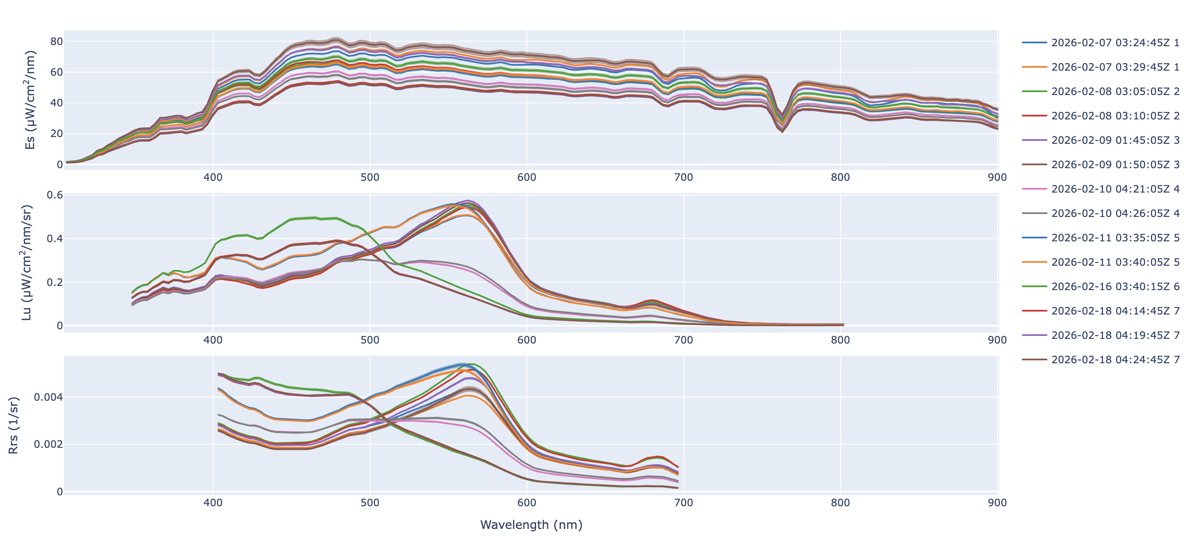
Figure 1. Irradiance (top), radiance at 0.17m (middle) and derived reflectance obtained on Perseverance in its Southern Ocean cruise in 2026. Multiple curve denote different5min averaging.
All raw data and calibration files are in the compressed folder HyperPro_Perseverance_2026.

References:
Boss, E., L. Taylor, S. Gilbert, K. Gundersen, N. Hawley, C. Janzen, T. Johengen, H. Purcell, C. Robertson, D. W. Schar, G. J. Smith, M. N. Tamburri, 2009. Comparison of inherent optical properties as a surrogate for particulate matter concentration in coastal waters. Limnology and Oceanography: Methods 7, pp. 803-810.

Chase, A. P., E. Boss, I. Cetinic and W. Slade, 2017. Estimation of Phytoplankton Accessory Pigments from Hyperspectral Reflectance Spectra: Toward a Global Algorithm. Journal of Geophysical Research: Oceans, 122. https://doi.org/10.1002/2017JC012859

IOCCG Protocol Series (2018). Inherent Optical Property Measurements and Protocols:
Absorption Coefficient, Neeley, A. R. and Mannino, A. (eds.), IOCCG Ocean Optics and
Biogeochemistry Protocols for Satellite Ocean Colour Sensor Validation, Volume 1.0,
IOCCG, Dartmouth, NS, Canada.

Lee Z.-P., K. L. Carder, T. G. Peacock, C. O. Davis, and J. L. Mueller, (1996). Method to derive ocean absorption coefficients from remote-sensing reflectance, Appl. Opt. 35(3), 453–462.

Sullivan J. M., M. S. Twardowski , J. R. Zaneveld, C. Moore, A. Barnard, P. L. Donaghay, and B. Rhoades, 2006: The hyper-spectral temperature and salinity dependent absorption of pure water, salt water and heavy salt water in the visible and near-IR wavelengths (400–750 nm). Appl. Opt., 45: 5294–5309.

Quan X., and E. S. Fry (1995), Empirical equation for the index of refraction of seawater, Appl. Optics, 34, 3477–3480.

