Perseverance, 2026 (January 20th 2026 – March 9th 2026) ACs Processing Report V1
Emmanuel BOSS, Guillaume BOURDIN, Allison CHASE, March 2026
Measurements
Hyperspectral absorption and attenuation were measured continuously on board the S/V Perseverance during the Perseverance Antarctic expedition from January 20, 2026, to March 9, 2026, using a WetLabs ACS spectrophotometer (serial number 057). The AC spectrophotometer was set after a switching system running 0.2 um filtered sea water through the instrument the first 10 minutes of every hour and total (“normal”) seawater was flowing the rest of the time. This setup allows to retrieve particulate absorption and attenuation independently from the instrument drift and the biofouling effect (Slade et al., 2010). The data were logged with a home-grown data-logger (Inlinino, http://inlinino.readthedocs.io/). The ACs was cleaned every 5-7 days and the filters were changed approximately once a week. Addtionally, because the AC-s was set inline with a Jena FerryBox, a cleaning process took place every day between 11:33-11:43pm which flushed a mild acid through the instrument .
Processing notes
Data was processed following Boss et al. (2019), using a custom software for in-line optical data processing (https://github.com/OceanOptics/InLineAnalysis/commit/df7246258fcf039a099ffab631ab6218b810cd35).
All in-line instruments were logged on the same computer which was synchronized with the ship’s GPS date/time and latitude/longitude over the NMEA. Total and filtered data were first separated according to flow data of the in-line data. Automatic QC was applied to the raw data using a feature of the AC meter where the two linear spectrophotometers do not align well between 560 to 600 nm, removing entire raw spectrum when the following criteria is met:
$flag=\max\left(a_{\left(560nm 600nm\right)}\right)>F*mean(a_{\left(500nm 550nm\right)})$ (1)
With $a_{\left(560nm 600nm\right)}$ the difference of absorption between consecutive wavelengths in the range 560nm and 600nm (function diff.m in Matlab) and F being a constant adjusted so that no more than 15% of raw spectra are deleted and the raw, for each channel (a and c) and for each type of water measured (filtered vs total). For each minute of the total seawater measurement, the signal between the 2.5th and 97.5th percentiles are averaged, and their standard deviation is kept for reporting. The automatic quality control (QC) and the 2.5th to 97.5th percentiles averaging filters out noisy spikes from bubbles. The entire time series of measurement was automatically QCed to remove artefacts and manually checked and QCed for obviously bad measurements (saturated sensor, low flow rate, bubbles, and bad filtered seawater measurements). Particulate spectra are computed as the difference between total and interpolated dissolved spectra from the periods before and after the ‘total’ measurement periods (e.g. Slade et al. (2010), Boss et al. (2013)). One difference, however, is that we use a CDOM fluorometer to assist in the interpolation in between the dissolved point based on a relationship we derive between the fluorometer and the absorption or attenuation spectra during filtration times. This allows for an improved correction that can react to fronts and other features modulating CDOM that may be encountered in between filtered measurements.
All a_{p} and c_{p} spectra were unsmoothed following the method in Chase et al. (2013). temperature/salinity corrections are done based the AC-s specific temperature/salinity tables of Sullivan et al. (2006). Additionally, all spectra were inspected by a trained operator and unreasonable spectra were removed. The scattering correction applied is inspired from two corrections (Zaneveld et al., 1994, proportional correction method and that from Rottgers et al., 2013, an NIR offset):

$$a_{p,corr}\left(λ\right)=a_{p,Tcorr}\left(λ\right)-a_{p,Tcorr}\left(715\right)\frac{c_{p,Tcorr}\left(λ\right)}{c_{p,Tcorr}\left(715\right)}{+0.083a}_{p,Tcorr}\left(715\right).$$
Where the subscript Tcorr refers to the blank corrected data corrected for the dependence of sea water on salinity and temperature. We found this scattering correction to work best when compared to measurements of particulate absorption done in an integrating sphere by colleagues at the Laboratoire d’Oceanographie de Villefranche based on the state-of-the-art protocols for the Tara Europa expedition.
Due to extensive bubbles in certain periods when crossing the Antarctic circumpolar current, we removed any spectra that had too much variance. Empirically, a criterion of uncertainty in $a_{p,corr}$ or $c_{p,corr}$ divided by their signal >0.2 was used to remove such spectra.
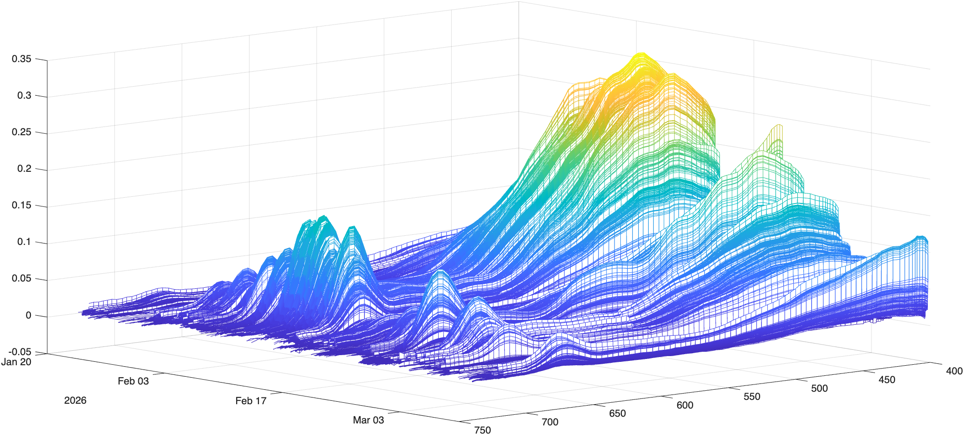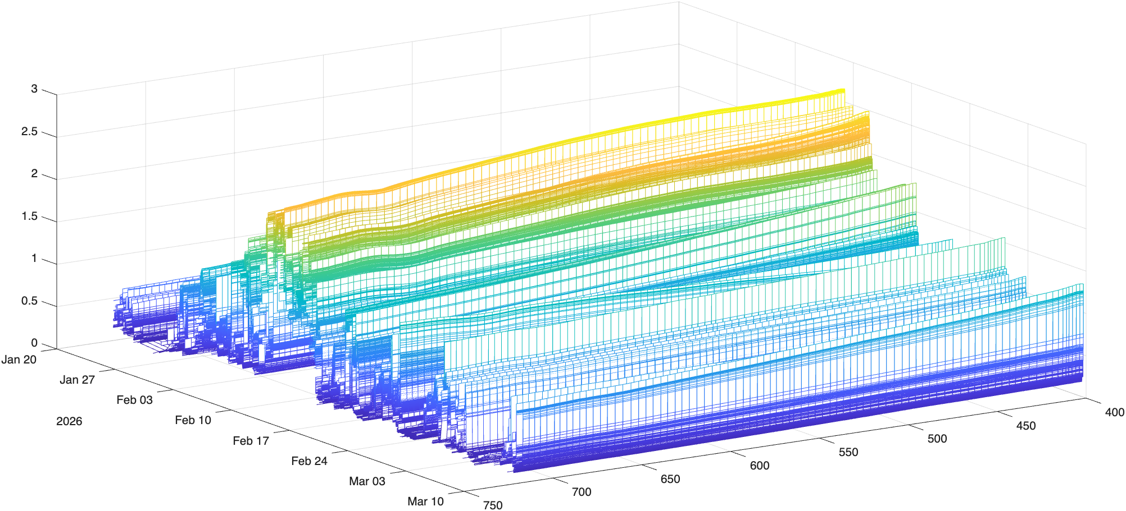
Figure 1: All the particulate absorption and attenuation spectra between 2026/01/20 and 2023/3/9 measured with the ACS57
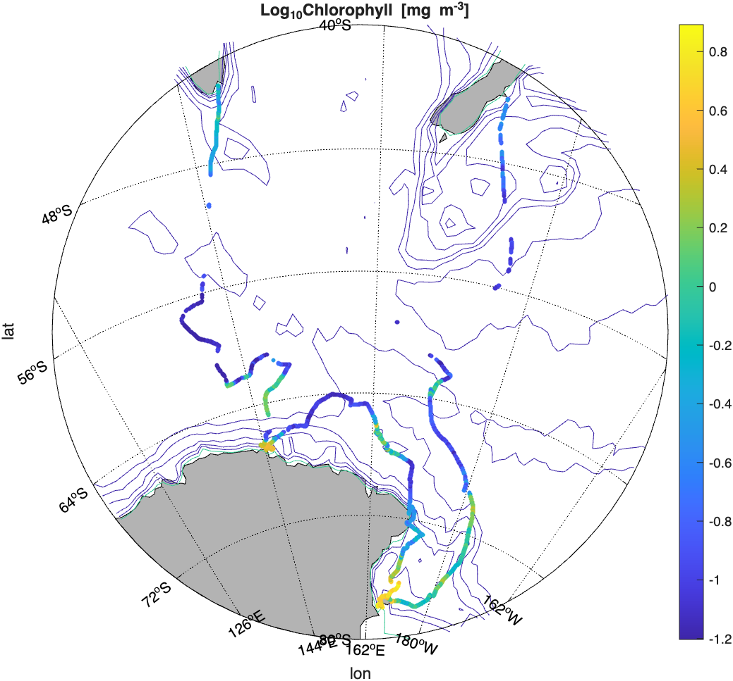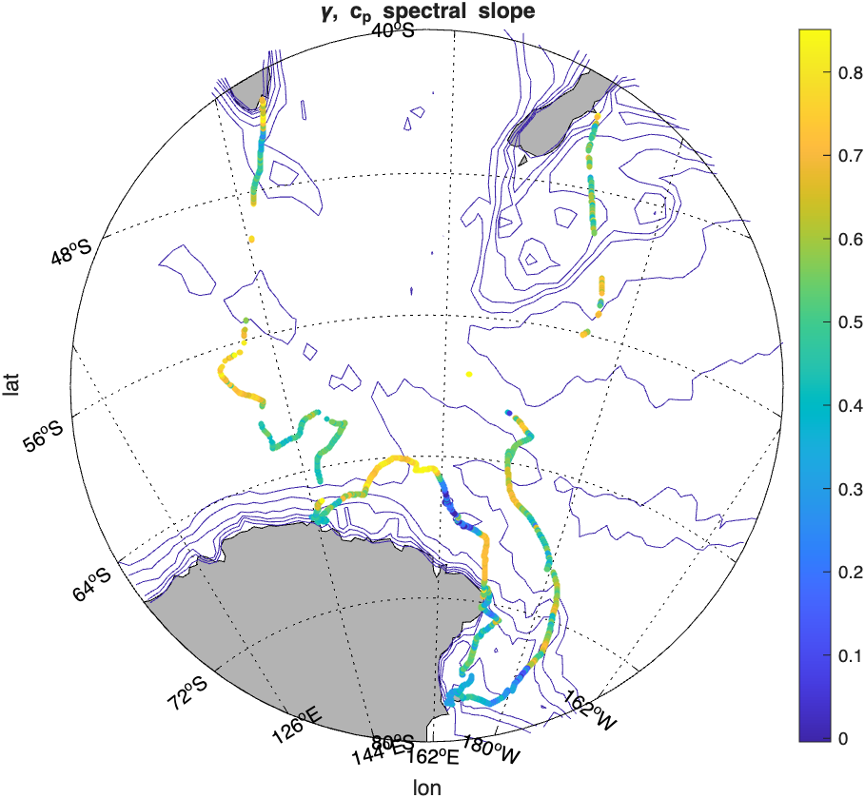
Figure 2: Preliminary chlorophyll concentration estimated from absorption line height and using relation Boss et al. (2013) measured with the ACS057. Holes represent areas that were removed using our QC procedures, mostly due to bubbles.

References:
Boss, E., Haëntjens, N., Ackleson, S.G., Balch, B., Chase, A., Dall’Olmo, G., Freeman, S., Liu, Y., Loftin, J., Neary, W., Nelson, N., Novak, M., Slade, W.H., Proctor, C., Tortell, P., Westberry, T.K., 2019. Inherent Optical Property Measurements and Protocols: Best Practices for the Collection and Processing of Ship- Based Underway Flow-Through Optical Data (v4.0). IOCCG Protocol Series 4, 17. http://dx.doi.org/10.25607/OBP-458
Chase, A., Boss, E., Zaneveld, R., Bricaud, A., Claustre, H., Ras, J., Dall’Olmo, G., Westberry, T.K., 2013. Decomposition of in situ particulate absorption spectra. Methods in Oceanography 7, 110–124. https://doi.org/10.1016/j.mio.2014.02.002
Haëntjens, N., and E. Boss. 2020. Inlinino: A modular software data logger for oceanography. Oceanography 33(1):80–84, https://doi.org/10.5670/ oceanog.2020.112.
Röttgers, R., McKee, D., Woźniak, S.B., 2013. Evaluation of scatter corrections for ac-9 absorption measurements in coastal waters. Methods in Oceanography 7, 21–39. https://doi.org/10.1016/j.mio.2013.11.001
Slade, W.H., Boss, E., Dall’Olmo, G., Langner, M.R., Loftin, J., Behrenfeld, M.J., Roesler, C., Westberry, T.K., 2010. Underway and Moored Methods for Improving Accuracy in Measurement of Spectral Particulate Absorption and Attenuation. Journal of Atmospheric and Oceanic Technology 27, 1733–1746. https://doi.org/10.1175/2010JTECHO755.1
Sullivan, J.M., Twardowski, M.S., Zaneveld, J.R.V., Moore, C.M., Barnard, A.H., Donaghay, P.L., Rhoades, B., 2006. Hyperspectral temperature and salt dependencies of absorption by water and heavy water in the 400-750 nm spectral range. Appl. Opt. 45, 5294. https://doi.org/10.1364/AO.45.005294
Zaneveld, J. R. V., J.C. Kitchen, C.M. Moore, 1994. The scattering error correction of reflecting-tube absorption meters Proc. SPIE, 2258, 44-55.

