Underway Log

KM24 SO-PACE

Tahiti -> Honolulu

Nov 28 – Dec 15 2024

Ali Chase

\*\* note: there is a sperate log just for the IFCB on the IFCB laptop, and a separate log for pySAS on the Toughbook/in the pysas data folder \*\*

Nov 28

Problem with pysas not working, and sink for underway leaking a lot onto the floor

Engineer fixed sink, underway started at 03:50 UTC (11/29)

03:57 UTC 11/29 IFCB started on flow-through

pySAS turned on late afternoon local time

Nov 29

* ALFA has pico error; restarted – filename with extension 010000
* Accidently closed FRRF software, restarted – filename 20241129
* ALFA not working; pico error repeatedly; first tried changing the power supply, still no, then switched back to the USB hub borrowed from OTG and working (start at 03:00 UTC Nov 30)
* HPLC sampling (duplicate) at 0039-0044 (Nov 30 UTC). Patchy clouds.
* Cleaning of alfa, frrf, ac-s, and 2x fluorometers between 9:30-11:30 local time

Nov 30

* HPLC sampling at 23:29 – 23:36 UTC (triplicate)
* ALFA and FRRF cleaning start at 07:56 UTC (12/1), finished at 08:42 UTC (12/1)

Dec 1

* FRRF computer was doing a windows update when I arrived to the lab this morning. Not sure what time in the night it happened; software restarted at 18:47 UTC
* ALFA appears to have stopped seeing filter events sometime in the middle of the night (see pic below). Fow didn’t have enough pressure to be moving water through the instrument. Opened the seawater tap slightly and also opened the orange knob slightly to increase flow.

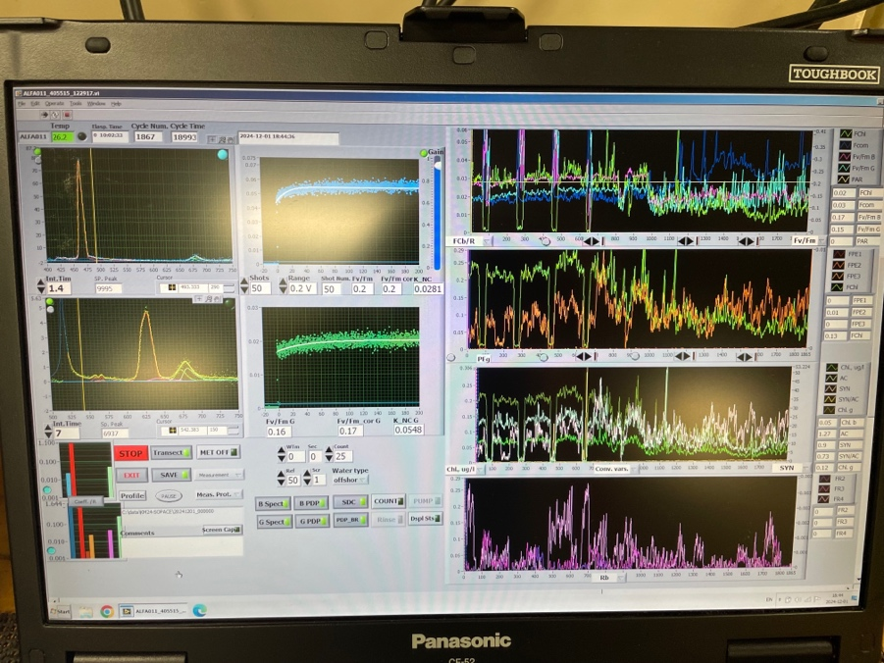

The sample in the pic above (20241201) was started around 0900 UTC on 12/1; it looks like there were four good hours before the water stopped flowing (no filter events seen). Water flow rate adjusted at 18:50 UTC on 12/1. So the 10 hours of data between 0900 and 1900 UTC on 12/1 are not good data.

* Pennate diatom ‘bloom’ in IFCB data on this day! Then IFCB got bubbles and then stopped working (syringe at -1 issue). Waiting to hear back from McLane on how to change rotary valve optical sensor.
* HPLC sampling at 22:35 – 22:41 UTC (triplicate)
* Full system cleaning started at 07:09 UTC (12/2)
* Ac-s not logging or collecting data since 0400 UTC 12/2. Ac-s 091 was replaced with AC-s 111 (but using the a tube from 91 to minimize leaks).
* Full system cleaning finished at about 10:00 UTC 12/2. ALFA had a high temp warning and so we left it off for a few hours to cool down. ALFA was restarted around 15:00 UTC 12/2.
* Worked with McLane; IFCB working again as of about 1800 UTC on 12/2.

Dec 2

* Underway computer had done a windows update; everything re-started at 21:00 UTC 12/2
* HPLC water collection at 22:37 – 22:45 UTC

Dec 3

* HPLC water at 23:12 -23:19 UTC
* Cleaning alfa, frrf, acs, fluoros from 12/4 07:00 to 08:14 UTC

Dec 4

* ALFA crashed with pico error, restarted
* ALFA stopped and restarted at ~23:00 UTC; no error but didn’t seem to be adding new data to the graphs
* HPLC water at 21:57 – 22:01 (before filter switched on)
* Cleaning of ALFA and FRRF at 0700 UTC (12/5)

Dec 5

* HPLC water at 22:33 - 22:39 UTC
* Windy & choppy (white caps) today
* ALFA pico error – restarted at 17:40 UTC
* ALFA restart at 00:10UTC (12/6) – no pico error, but the spectra plots stopped showing spectra and the time series values went to zero
* Stopped for cleaning/DIW in all inst. @ 06:10 UTC (12/6)
* Started again at 07:55 UTC 12/6

Dec 6

* HPLC water at 21:51 – 21:57 UTC; windy/choppy/white caps
* Underway laptop acting slow; restarted everything (& deleted hyper-bb files off instrument) at 03:08 UTC (12/7)
* ALFA and FRRF cleaning at 06:30 UTC (12/7). Finished at 06:57

Dec 7

* HPLC water at 22:21 – 22:27
* Cleaning start at 06:09 UTC 12/8 – big 0.2 filter changed
* Data collection started again at 07:32 12/8 – filter canister not filling completely?

Dec 8

* HPLC water at 22:22 – 22:28
* ALFA and FRRF stopped for cleaning at 06:30 12/9

Dec 9

* HPLC water at 21:55 – 22:00 UTC
* 22:59 UTC – ALFA crash and re-start
* Cleaning of all instruments at 06:10 – 07:35 UTC 12/10

Dec 10

* ALFA crashed in the night; restarted at 17:23 UTC
* HPLC water at 22:21 – 22:28 UTC. Big red copepod on one filter, also some big red copepods in coarse filter when cleaned last night.
* ALFA crashed, restart at 03:07 UTC (12/11)
* Underway laptop did an update; everything re-started at 04:23 UTC (12/11)
* ALFA and FRRF cleaning at 6:35 – 07:01 UTC 12/11

Dec 11

* Stormy/overcast/rainy (no radiometer cleaning)
* 16:34 UTC – Java error on FRRF laptop; resolved w/laptop restart at 18:56 UTC
* AFLA crash/restart at 22:40 UTC
* HPLC (duplicates instead of triplicates) water taken at 22:42 – 22:46 UTC
* Ac-s, fluorometers, ALFA and FRRF cleaning at 06:37 – 07:20 UTC (12/12), with force filter both before and after cleaning

Dec 12

* HPLC water at 22:49 – 22:56
* Windy, partly sunny, white caps
* FRRF and ALFA cleaning at 06:40 – 07:30 UTC (12/13)

Dec 13

* ALFA crashed in the night, restarted at 17:33 UTC
* Noticed the flow rate was low (since last cleaning? Not sure) so opened up at sink more, at 19:00 UTC
* HPLC water at 22:29 – 22:35 UTC. Noticeably less color on filters (and fewer images/plankton in IFCB)
* Cloudy, windy
* Stopped for big cleaning (all instruments) at 06:10 – 07:34 UTC 12/14

Dec 14

* HPLC water at 22:21 – 22:27 UTC
* Clear skies at time of PACE overpass
* A few hours stopped in the afternoon to recover a glider; lots of boat repositioning, rough seas and windy
* ALFA and FRRF cleaning 0605 – 0630 UTC 12/15

Dec 15

* ALFA crash & restart 3x. stopped for cleaning and packing at 23:30 UTC
* HPLC water at 23:16-23:21 UTC
* Sunny and clear and calm seas for PACE overpass!! Go PACE!