PVST SO-PACE TN444 (May - June 2024) ACs Processing Report V1
Guillaume BOURDIN and Alison CHASE, August 2025
Measurements
Hyperspectral absorption and attenuation were measured continuously on board the R/V Thomas G. Thompson during the PVST SO-PACE TN444 cruises from 2025-05-05, to 2025-06-15, using a WetLabs ACS spectrophotometer (serial number 111). The AC spectrophotometer was set after a switching system running 0.2 um filtered sea water through the instrument the first 10 minutes of every hour and total (“normal”) seawater was flowing the rest of the time. This setup allows to retrieve particulate absorption and attenuation independently from the instrument drift and the biofouling effect (Slade et al., 2010). The data were logged with a home-grown data-logger (Inlinino, http://inlinino.readthedocs.io/). The ACs was cleaned every 2 days, and the filters were changed approximately once a week.
Processing notes
Data was processed following Boss et al. (2019), using a custom software for in-line optical data processing (https://github.com/OceanOptics/InLineAnalysis/commit/df7246258fcf039a099ffab631ab6218b810cd35).
All in-line instruments were logged on the same computer which was synchronized with the ship’s GPS date/time and latitude/longitude over the NMEA. Total and filtered data were first separated according to flow data of the in-line data. Automatic QC was applied to the raw data using a feature of the AC meter where data from the two filter wheels of the spectrophotometer do not align well between 560 to 600 nm, removing entire raw spectrum when the following criteria is met:
$flag=\max\left(a_{\left(560nm 600nm\right)}\right)>F*mean(a_{\left(500nm 550nm\right)})$ (1)
With $a_{\left(560nm 600nm\right)}$ the difference of absorption between consecutive wavelengths in the range 560nm and 600nm (function diff.m in Matlab) and F being a constant adjusted so that no more than 15% of raw spectra are deleted and the raw, for each channel (a and c) and for each type of water measured (filtered vs total). For each minute of the total seawater measurement, the signal between the 2.5th and 97.5th percentiles are averaged, and their standard deviation is kept for reporting. The automatic quality control (QC) and the 2.5th to 97.5th percentiles averaging filters out noisy spikes from bubbles. The entire time series of measurement was automatically QCed to remove artefacts and manually checked and QCed for obviously bad measurements (saturated sensor, low flow rate, bubbles, and bad filtered seawater measurements). Particulate spectra are computed as the difference between total and linearly interpolated dissolved spectra from the periods before and after the ‘total’ measurement periods (e.g. Slade et al. (2010), Boss et al. (2013)).
All a_{p} and c_{p} spectra were unsmoothed following the method in Chase et al. (2013). temperature/salinity corrections are done based the AC-s specific temperature/salinity tables of Sullivan et al. (2006). Additionally, all spectra were inspected by a trained operator and unreasonable spectra were removed.
The scattering correction applied is based on a blend of two corrections (Zaneveld et al., 1994, proportional correction method and an offset in red inspired from that of Rottgers et al., 2013, See Appendix below), and is tuned with discrete measurements done by the LOV group throughout the Tara Europa two-year expedition (Bourdin et al. in prep):
$$a_{p,corr}\left(λ\right)=a_{p,Tcorr}\left(λ\right)-a_{p,Tcorr}\left(715\right)\frac{c_{p,Tcorr}\left(λ\right)}{c_{p,Tcorr}\left(715\right)}+0.0831a_{ac-s,m}.$$
Where T,corr- corrected for temperature changes relative to factory calibration.
Note that we have flagged a variety of spectra. The flags are NOT in the SeaBASS data. If you would like access to the flags please contact us (currently not supported by SeaBASS) and we will send you .csv or .mat files which includes those flags.
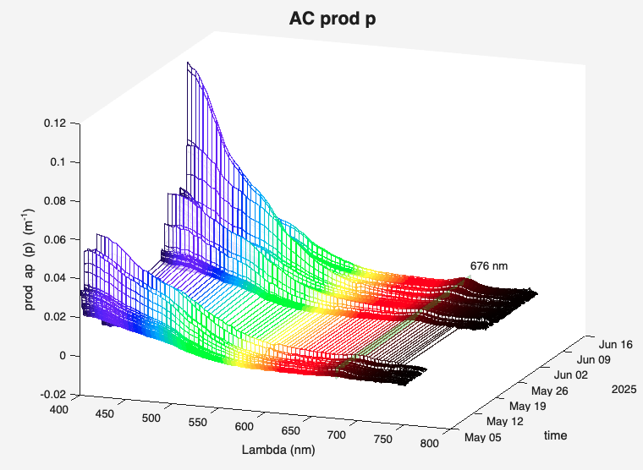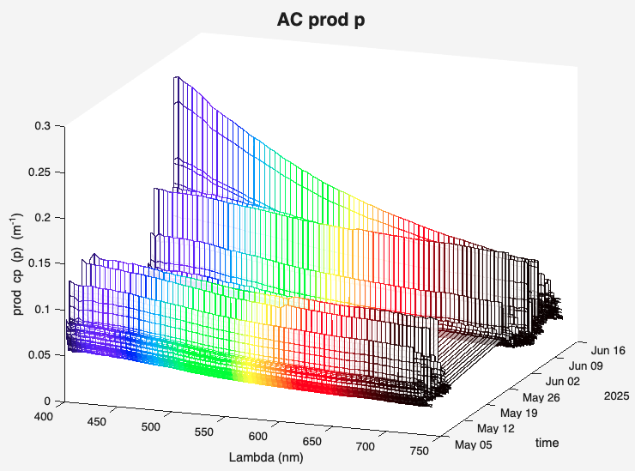
Figure 1: Particulate absorption and attenuation spectra measured during the PVST SO-PACE TN444 cruise with the ACS111

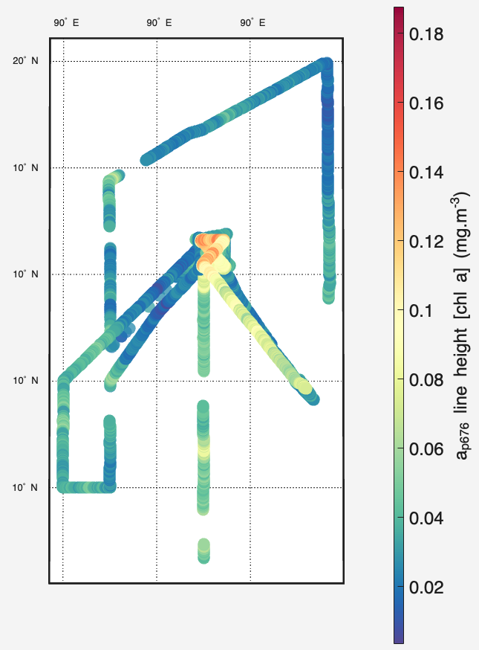
Figure 3: Preliminary chlorophyl concentration estimated from absorption line height and using relation Boss et al. (2013) measured in the PVST SO-PACE TN444 cruise with the ACS111.

References:
Boss, E., Haëntjens, N., Ackleson, S.G., Balch, B., Chase, A., Dall’Olmo, G., Freeman, S., Liu, Y., Loftin, J., Neary, W., Nelson, N., Novak, M., Slade, W.H., Proctor, C., Tortell, P., Westberry, T.K., 2019. Inherent Optical Property Measurements and Protocols: Best Practices for the Collection and Processing of Ship- Based Underway Flow-Through Optical Data (v4.0). IOCCG Protocol Series 4, 17. http://dx.doi.org/10.25607/OBP-458
Chase, A., Boss, E., Zaneveld, R., Bricaud, A., Claustre, H., Ras, J., Dall’Olmo, G., Westberry, T.K., 2013. Decomposition of in situ particulate absorption spectra. Methods in Oceanography 7, 110–124. https://doi.org/10.1016/j.mio.2014.02.002
Haëntjens, N., and E. Boss. 2020. Inlinino: A modular software data logger for oceanography. Oceanography 33(1):80–84, https://doi.org/10.5670/ oceanog.2020.112.
Röttgers, R., McKee, D., Woźniak, S.B., 2013. Evaluation of scatter corrections for ac-9 absorption measurements in coastal waters. Methods in Oceanography 7, 21–39. https://doi.org/10.1016/j.mio.2013.11.001
Slade, W.H., Boss, E., Dall’Olmo, G., Langner, M.R., Loftin, J., Behrenfeld, M.J., Roesler, C., Westberry, T.K., 2010. Underway and Moored Methods for Improving Accuracy in Measurement of Spectral Particulate Absorption and Attenuation. Journal of Atmospheric and Oceanic Technology 27, 1733–1746. https://doi.org/10.1175/2010JTECHO755.1
Sullivan, J.M., Twardowski, M.S., Zaneveld, J.R.V., Moore, C.M., Barnard, A.H., Donaghay, P.L., Rhoades, B., 2006. Hyperspectral temperature and salt dependencies of absorption by water and heavy water in the 400-750 nm spectral range. Appl. Opt. 45, 5294. https://doi.org/10.1364/AO.45.005294
Zaneveld, J. R. V., J.C. Kitchen, C.M. Moore, 1994. The scattering error correction of reflecting-tube absorption meters Proc. SPIE, 2258, 44-55.

Appendix: Analysis of the relationship between spectrophotometer based particulate absorption and AC-s based particulate absorption at 715nm during the Tara Europa expedition.

Emmanuel Boss, David Doxaran and Guillaume Bourdin

In the recent Tara Europa expedition (2023-2024), an AC-S (Seabird Sci.) was deployed
as part of the inline system (two different sensors, one in each year). In addition, water was taken at stations for lab analysis at LOV using a spectrophotometer with an integrating sphere.

The expedition has sampled waters with very different particulate sources (riverine, Baltic, oceanic, Fig. 1) and it is of interest to revisit the scattering correction used for the AC-S of which the offset at 715nm is dealt with here.
Figure A1. Location of stations used in comparison of particulate absorption at 715nm

Particulate IOPs were estimated from the difference between total IOPs and interpolated filtered IOPs where the interpolation method was based on a CDOM fluorometer .

Rottgers et al., 2013 found for coastal waters from the Elbe river, North Sea and cultures, comparing AC-S data to an integrating sphere, that:
${a\left(715\right)}_{psicam}=0.212a_{ac-s,m}^{1.135}$ (A1)

Where $a_{ac-s,m}^{1.135}$ is the particulate absorption of the AC-s. A following study by Pitarch et al., 2016 (N=101, waters around Italy), found another relation to work better based on closure with remote-sensing reflectance:
${a\left(715\right)}_{Pitarch}=0.06a_{ac-s,m}^{0.7}$. (A2)
Here we derive a similar equation by comparing the AC-S measurements with the measurements at LOV (N=177):
${a\left(715\right)}_{Trec}=0.105a_{ac-s,m}^{1.11}$. (A3)
We find a simple linear regression to also work well:
${a\left(715\right)}_{Trec}=0.0831a_{ac-s,m}$, (A4)
That is, on average, ~91.5% of the signal measured by the a-tube at 715nm being due to scattering.
Figure A2. Comparison of AC-s absorption data with no correction (left top), corrected based on Rottgers et al., 2013 (top Right, eq. A1)), corrected based on Pitarch et al., 2016 (bottom left, Eq. A2) and based on the robustfit linear regression of these data (bottom right Eq. A3 in blue, with green symbols those for the linear Eq. A4). We used the 164 pts, out of 177 having environmental variability (90th percentile) smaller than +/-0.01m⁻¹. Highest correlations are for the new and Rottgers’ corrections with R²~0.9 for both linear and log-transformed data. Black lines are the 1-1 lines.

Pitarch, J. G. Volpe, S. Colella, R. Santoleri, and V. Brando, 2016, Absorption correction and phase function shape effects on the closure of apparent optical properties, Appl. Opt. 55, 8618-8636, https://doi.org/10.1364/AO.55.008618.
Röttgers, R., D. McKee, and S. B. Woźniak, 2013, Evaluation of scatter corrections for ac-9 absorption measurements in coastal waters, Methods in Oceanography, 7,21-39, https://doi.org/10.1016/j.mio.2013.11.001.

