PVST SO-PACE TN444 (May – June 2025) HyperBB Processing Report V1
Guillaume BOURDIN, Emmanuel BOSS, Xiaodong Zhang, and Alison CHASE August 2025
Measurements
Volume scattering function (VSF) at 134+1.5 deg at 430, 440, 450, 460, 470, 480, 490, 500, 510, 520, 530, 540, 550, 560, 570, 580, 590, 600, 610, 620, 630, 640, 650, 660, 670, 680, 690 and 700nm wavelengths were measured continuously on board the R/V Thomas G. Thompson during the PVST SO-PACE TN444 cruise from 2025-05-05, to 2025-06-15 in the Indian Ocean.
A WetLabs Sequoia Scientific HyperBB (serial number 8005) was set in 2L specially constructed flow-through chamber mounted on an underway continuous sampling system. Measurements were done in a protocol using switching system, running 0.2 um filtered sea water through the box during the first 10 minutes of every hour, and total (non-filtered) seawater the rest of the hour. This setup allows to retrieve particulate VSF (β_{p}) independently from instrument drift, box effect, biofouling, and particle accumulation happening in the box.
The data was logged with a publicly-available home-grown data-logger (Inlinino, http://inlinino.readthedocs.io/). The Box was cleaned approximately every 4 days and the filters were changed weekly or when the flow speed during a filtered measurements was consistently lower than 2 LPM.
Processing notes
Data was processed following Boss et al. (2019) with a few modification as described below, using a custom software for in-line optical data processing (https://github.com/OceanOptics/InLineAnalysis/commit/df7246258fcf039a099ffab631ab6218b810cd35).
All in-line instruments were logged on the same computer which was synchronized with the ship’s GPS date/time and latitude/longitude over the NMEA. Total and filtered data were first separated according to flow data of the in-line data. Total and filtered data were first separated according to flow data of the in-line data. For each five minutes of the total seawater measurement, the signal between the 2.5th and 97.5th percentiles are averaged, and their standard deviation is kept for reporting. The automatic QC and the 2.5th to 97.5th percentiles averaging filter out noisy spikes from bubbles and rare large particles. Both total and filtered measurements were individually T/S corrected based on method from Zhang et al. (2009) (betasw_ZHH2009.m) using temperature and salinity measurements recorded with a SeaBird SBE38 and SBE45 mounted on the same water circuit.
The purpose of measurements of dissolved fraction and their removal from the total signal is designed to:
- Address changes in the dark current, if any.
- Remove contribution of chamber reflectance.
- Remove contribution of large particles/swimming organisms that manage to stay in the chamber over long times.
They do not correct for window fouling, as the latter will reduce the signal of both dissolved and total (and difference between them). We will denote the above offset by $Δ$.
If there is a significant amount of attenuating material in the chamber, this attenuation needs to be corrected for. For instrument calibrated with a plaque (e.g. Hyper-bb), the measurement includes the contribution of water, dissolved materials and particles. Note that the attenuation due to water (not salts) is taken care of by the calibration procedure (instrument is calibrated with water in the tank). The filtered measurement of the VSF ($β_{measured,0.2}\left(θ_{0}\right))$ relates to IOPs as follows (Zhang et al. in prep):
$$β_{measured,0.2}\left(θ_{0}\right)=\left(β_{sw}\left(θ_{0}\right)+β_{g}\left(θ_{0}\right)\right)e^{-k_{0.2}δ}, k_{0.2}=a_{s}+a_{g}+f(β_{s}\left(θ\right)+β_{g}\left(θ\right))$$
Where s and g denote salts and dissolved substances, respectively and $δ$ is the average pathlength (=0.1058 m). Based on an analysis by X. Zhang (11/2024), $θ_{0}=134±1.5° .$The measurement of the total fraction ($β_{measured,total}\left(θ_{0}\right))$relates to IOPs as follows:
$$β_{measured,total}\left(θ_{0}\right)=\left(β_{sw}\left(θ_{0}\right)+β_{g}\left(θ_{0}\right)+β_{p}\left(θ_{0}\right)\right)e^{-k_{total}δ},$$
$$k_{total}=a_{s}+a_{g}+a_{p}+f\left(β_{s}\left(θ\right)+β_{g}\left(θ\right)+β_{p}\left(θ\right)\right)=k_{0.2}+a_{p}+f\left(β_{p}\left(θ\right)\right).$$
Where $k$ an effective attenuation. Note that effects of salinity on absorption can also be neglected ($a_{s}\sim 0)$ and will be ignored hereon.
Taking the difference between the two measurements (which takes care of wall effects and fouling if both are similar for the two measurements):
$${β_{measured,total}\left(θ_{0}\right)-β}_{measured,0.2}\left(θ_{0}\right)= \left(β_{s}\left(θ_{0}\right)+β_{g}\left(θ_{0}\right)+β_{p}\left(θ_{0}\right)\right)e^{-k_{total}δ}-\left(β_{s}\left(θ_{0}\right)+β_{g}\left(θ_{0}\right)\right)e^{-k_{0.2}δ}=β_{p}\left(θ_{0}\right)e^{-k_{total}δ}+\left(β_{s}\left(θ_{0}\right)+β_{g}\left(θ_{0}\right)\right)\left\{e^{-k_{total}δ}-e^{-k_{0.2}δ}\right\}$$
For small $kδ$’s, e.g. open ocean, we can expand in a Taylor Series: $e^{-kδ}=1-kδ-O\left(\frac{{\left(kδ\right)}^{2}}{2}\right).$
${β_{measured,total}\left(θ_{0}\right)-β}_{measured,0.2}\left(θ_{0}\right)=β_{p}\left(θ_{0}\right)\left(1-k_{total}δ\right)+\left(β_{s}\left(θ_{0}\right)+β_{g}\left(θ_{0}\right)\right)δ({k_{0.2}-k}_{total})$.
Neglecting the second term (assuming negligible scattering by salts and dissolved substances and given that $δ\left({k_{0.2}-k}_{total}\right)≪1$:
$β_{p}\left(θ_{0}\right)=\frac{\left\{{β_{measured,total}\left(θ_{0}\right)-β}_{measured,0.2}\left(θ_{0}\right)\right\}}{\left(1-k_{total}δ\right)}$. (1)

When $kδ$’s are larger, we go back to (neglecting $β_{s}\left(θ_{0}\right))$:
$${β_{measured,total}\left(θ_{0}\right)-β}_{measured,0.2}\left(θ_{0}\right)= \left(β_{g}\left(θ_{0}\right)+β_{p}\left(θ_{0}\right)\right)e^{-k_{total}δ}-β_{g}\left(θ_{0}\right)e^{-k_{0.2}δ}=β_{p}\left(θ_{0}\right)e^{-k_{total}δ}+β_{g}\left(θ_{0}\right)\left\{e^{-k_{total}δ}-e^{-k_{0.2}δ}\right\}$$
$$→β_{p}\left(θ_{0}\right)=\left\{{β_{measured,total}\left(θ_{0}\right)-β}_{measured,0.2}\left(θ_{0}\right)-β_{g}\left(θ_{0}\right)\left\{e^{-k_{total}δ}-e^{-k_{0.2}δ}\right\}\right\}e^{k_{total}δ}$$
Which, if we ignore scattering by salts and dissolved materials reduces to:
$β_{p}\left(θ_{0}\right)=\left\{β_{measured,total}\left(θ_{0}\right)-β_{measured,0.2}\left(θ_{0}\right)e^{-\left(k_{total}-k_{0.2}\right)δ}\right\}e^{k_{total}δ}$
The next step is to figure out the value of $k$. Zhang et al., 2021, argue for doing a MC simulation based on an assumed FF VSF (assuming we know the backscattering ratio, for example). Their results show that the Doxaran et al., 2016 method is reasonable as well. This method was devised for H-bb type instrument ($δ=0.1058m)$: with $k_{total}=a_{g}+a_{p}+3.3b_{p}$
$→β_{p}\left(θ_{0},λ\right)=\left\{β_{measured,total}\left(θ_{0},λ\right)\right\}e^{(a_{g}(λ)+a_{p}(λ)+6.6{×χ\left(θ_{0}\right)×π×β}_{p}\left({λ,θ}_{0}\right))×0.106}-β_{measured,0.2}\left(θ_{0},λ\right)e^{a_{g}\left(λ\right)×0.106}$(2)
For the processing here we used a LUT created by Zhang et al., 2024 to obtain the correction. The filtered VSF are based on the 25th percentile of data during the filtered period. We provided it the IOPs measured on the same underway continuous sampling system onboard the R/V Thomas G. Thompson:
- particulate absorption and beam attenuation
- a_{g}440 estimated from chlorophyll concentration measured from the ACS111:
  - $a_{g}(440){=0.2[a_{w}\left(440\right)+0.06A_{chl}(440)(Chl)}^{0.65}]$ (Morel and Maritorena, 2001 (appendix B))
  - $a_{g}(λ){=a_{g}\left(440\right)e}^{-0.014(λ-440)}$ (Bricaud et al. (1981))
Once the particulate VSF ($β_{p}\left(θ_{0},λ\right)=\left\{β_{measured,total}\left(134,λ\right)\right\}$) obtained we computed the particulate backscattering coefficient (b_{bp}) (nominal angle 134.
b_{bp}(λ)=2*π*χ(120°)*β _{p}(134°,λ).
χ(134°) = 1. 177 is the weighted mean of the data in table 6.1 in Sullivan et al., 2013 (and consistent with Boss and Pegau, 2001 and Zhang et al., 2021).
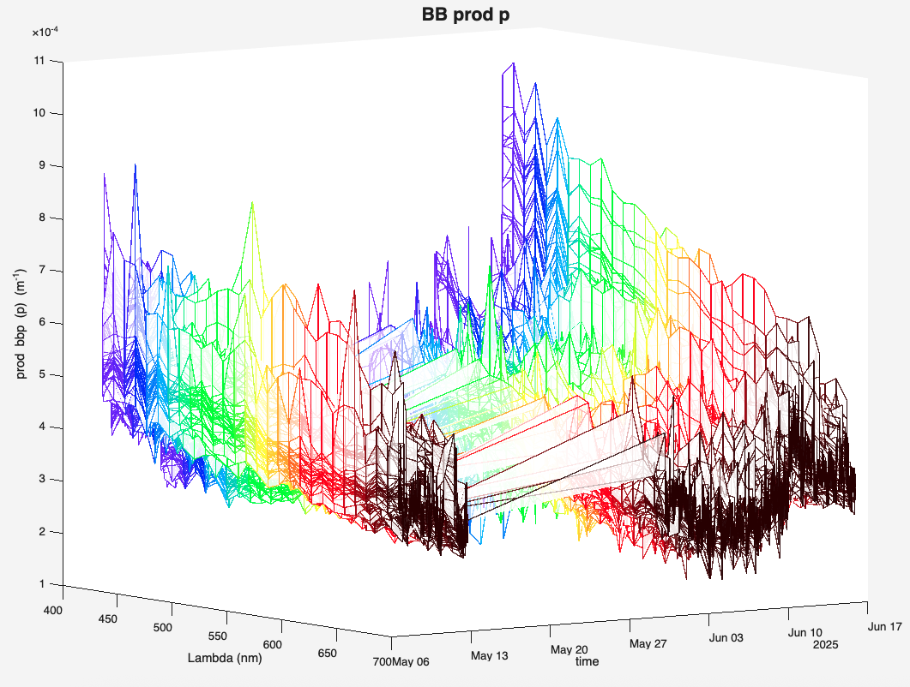
Figure 1: b_{bp} (from Hbb8005) in TN444.
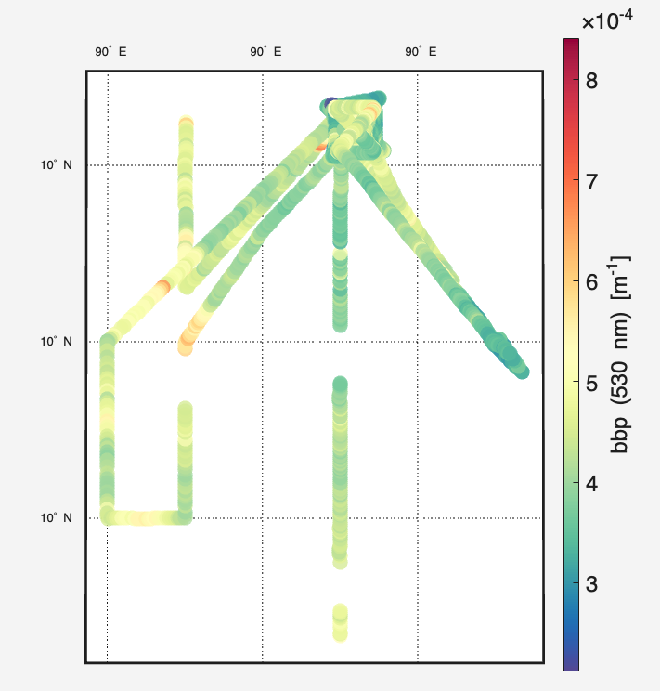
Figure 2: maps of b_{bp} at at 530nm from HyperBB8005
Instrument calibration
We performed a pre-cruise plaque calibration following on manufacturer procedure and applied its coefficients to the entire dataset (values in Table 1).
wavlength [nm] |  |  | 430 | 440 | 450 | 460 | 470 | 480 | 490 | 500
slope (mu) [Sr⁻¹ m⁻¹ count⁻¹] |  |  | 8.85e-04 | 1.03e-03 | 1.06e-03 | 1.25e-03 | 1.41e-03 | 1.64e-03 | 1.78e-03 | 1.94e-03
wavlength [nm] | 510 | 520 | 530 | 540 | 550 | 560 | 570 | 580 | 590 | 600
slope (mu) [Sr⁻¹ m⁻¹ count⁻¹] | 2.15e-03 | 2.39e-03 | 2.65e-03 | 2.94e-03 | 3.23e-03 | 3.44e-03 | 3.64e-03 | 3.99e-03 | 4.47e-03 | 4.84e-03
wavlength [nm] | 610 | 620 | 630 | 640 | 650 | 660 | 670 | 680 | 690 | 700
slope (mu) [Sr⁻¹ m⁻¹ count⁻¹] | 5.03e-03 | 5.16e-03 | 5.31e-03 | 5.68e-03 | 6.28e-03 | 7.13e-03 | 8.13e-03 | 9.17e-03 | 1.06e-02 | 1.30e-02
Table 1: calibration coefficients used to compute the VSF from the raw counts based on pre-cruise calibration.
References:
Boss E. and W.S. Pegau, 2001. Relationship of light scattering at an angle in the backward direction to the backscattering coefficient. Applied Optics, 40, 5503-5507.
Boss, E., Haëntjens, N., Ackleson, S.G., Balch, B., Chase, A., Dall’Olmo, G., Freeman, S., Liu, Y., Loftin, J., Neary, W., Nelson, N., Novak, M., Slade, W.H., Proctor, C., Tortell, P., Westberry, T.K., 2019. Inherent Optical Property Measurements and Protocols: Best Practices for the Collection and Processing of Ship- Based Underway Flow-Through Optical Data (v4.0). IOCCG Protocol Series 4, 17. http://dx.doi.org/10.25607/OBP-458
Doxaran, D., Leymarie, E., Nechad,B., Dogliotti, A., Ruddick, K., Gernez, P. and E. Knaeps, 2016. Improved correction methods for field measurements of particulate light backscattering in turbid waters, Opt. Express 24, 3615-3637.
Sullivan, J.M., Twardowski, M.S., Ronald, J., Zaneveld, V., Moore, C.C., 2013. Measuring optical backscattering in water, in: Light Scattering Reviews 7. Springer Berlin Heidelberg, Berlin, Heidelberg, pp. 189–224. https://doi.org/10.1007/978-3-642-21907-8_6
Zhang, X., Hu, L., and He, M.-X.: Scattering by pure seawater: Effect of salinity, Opt. Express, 17, 5698, https://doi.org/10.1364/OE.17.005698, 2009.
Zhang, X. , Hu, L., Gray, D. and Xiong, Y. 2021. Shape of particle backscattering in the North Pacific Ocean: the χ factor, Appl. Opt. 60, 1260-1266.
Zhang, X., E. Leymarie, E. Boss, and L. Hu, 2021, Deriving the angular response function for backscattering sensors, Appl. Opt. 60, 8676-8687.

