PVST SO-PACE TN444 (May - June 2025) LISST Processing Report V1
Guillaume BOURDIN and Alison CHASE, August 2025
Measurements
Beam attenuation and volume scattering function were measured continuously on board the R/V Kilo Moana during the HOT-PACE and SO-PACE PVST cruises from 2025-05-05, to 2025-06-15, using a Sequoia Scientifics LISST serial number 1183. The LISST was set after a switching system running 0.2 µm filtered sea water through the instrument the first 10 minutes of every hour and total (“normal”) seawater was flowing the rest of the time. This setup allows to retrieve particulate beam attenuation (cp) and particulate volume scattering function (VSF) independently from the instrument drift and the biofouling effect (Slade et al., 2010). The data were logged with a home-grown data-logger (Inlinino, http://inlinino.readthedocs.io/). The LISST was cleaned every 4 days, and the filters were changed approximately once a week.
Processing notes
Data was processed using standard procedures described in Boss et al. 2018, Boss et al. (2019), Agrawal and Pottsmith 2000, and Sequoia Processing Manual (2008), using a custom software for in-line optical data processing (https://github.com/OceanOptics/InLineAnalysis/commit/df7246258fcf039a099ffab631ab6218b810cd35).
All in-line instruments were logged on the same computer which was synchronized with the ship’s GPS date/time and latitude/longitude over the NMEA. Total and filtered data were first separated according to flow data of the in-line data.
For each minute of the total seawater measurement, the signal between the 2.5th and 97.5th percentiles are averaged, and their standard deviation is kept for reporting. The automatic quality control (QC) and the 2.5th to 97.5th percentiles averaging filters out noisy spikes from bubbles. The entire time series of measurement was automatically QCed to remove artefacts and manually checked and QCed for obviously bad measurements (saturated sensor, low flow rate, bubbles, and bad filtered seawater measurements). cp670, VSF are computed as the difference between total and linearly interpolated dissolved data from the periods before and after the ‘total’ measurement periods (e.g. Slade et al. (2010)). This procedure allows using the hourly dissolved measurements as “zscat” measurements, therefore “zscat” are not reported here. Particulate size distribution (PSD) was inverted using the manufacturer procedure and matlab function “invert_2014b.m”. Finally, all products were inspected by a trained operator and unreasonable data were removed.
The dcal provided by the manufacturer was generating an artefact in the VSF at 9.941° (ring 30). To correct the issue the original dcal(30) of 5.0166411 was replaced by 2.6 following manufacturer recommendations.

The calibration parameters used are:
VCC = 47447
Spherical Inversion
theta | dcal | ds (lower)
0.082 | 1.0179 | 1.25
0.096 | 0.9921 | 1.475
0.114 | 1.0108 | 1.7405
0.134 | 0.9949 | 2.0538
0.158 | 1.0044 | 2.4235
0.187 | 0.9989 | 2.8597
0.221 | 0.9986 | 3.3744
0.26 | 1.0042 | 3.9818
0.307 | 1.0001 | 4.6986
0.362 | 0.9989 | 5.5443
0.428 | 1.0009 | 6.5423
0.505 | 1.0004 | 7.7199
0.596 | 1.0011 | 9.1095
0.703 | 1.0005 | 10.7492
0.829 | 1.0214 | 12.6841
0.979 | 0.9999 | 14.9672
1.155 | 1.1116 | 17.6613
1.363 | 1.1207 | 20.8403
1.609 | 1.2494 | 24.5916
1.898 | 1.1643 | 29.018
2.24 | 1.3356 | 34.2413
2.643 | 1.2091 | 40.4047
3.119 | 1.0782 | 47.6776
3.681 | 1.7621 | 56.2595
4.344 | 1.5509 | 66.3863
5.126 | 2.5304 | 78.3358
6.049 | 2.5639 | 92.4362
7.138 | 3.5757 | 109.0747
8.424 | 3.9632 | 128.7082
9.941 | 2.6 | 151.8757
11.73 | 5.6381 | 179.2133
13.84 | 8.6882 | 211.4717
 |  | 249.5366

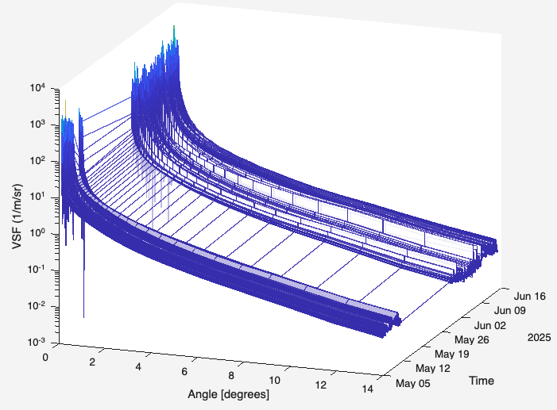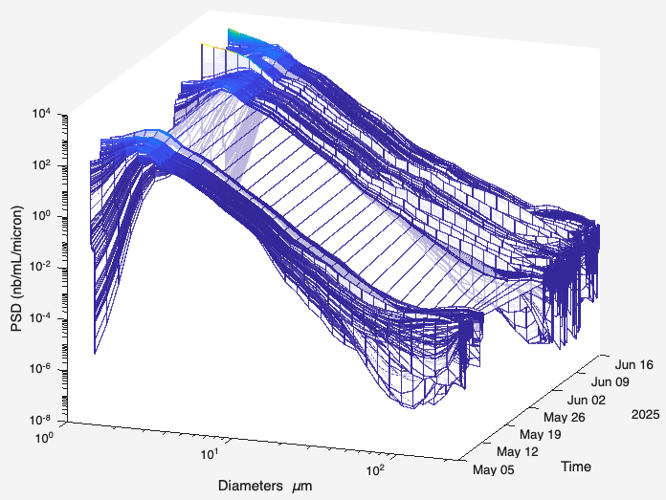
Figure 1: Example of particulate volume scattering function (left) and particle size distribution (right) 2025/05/05 and 2025/06/15.
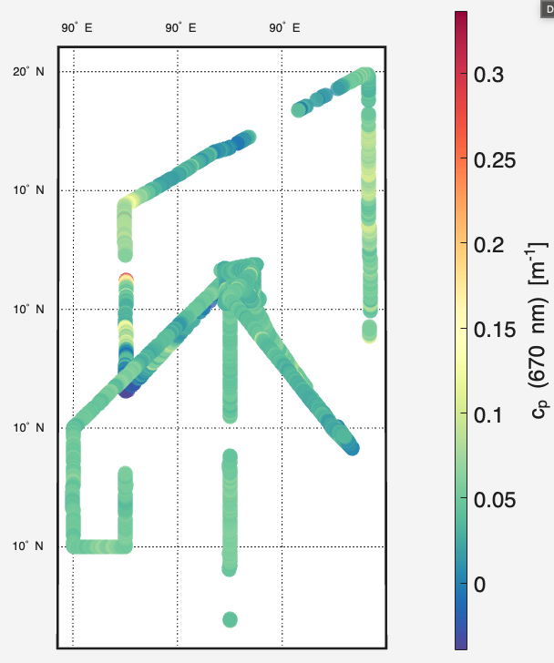
Figure 3: Time series and map of particulate beam attenuation measured with the LISST1183 during TN444

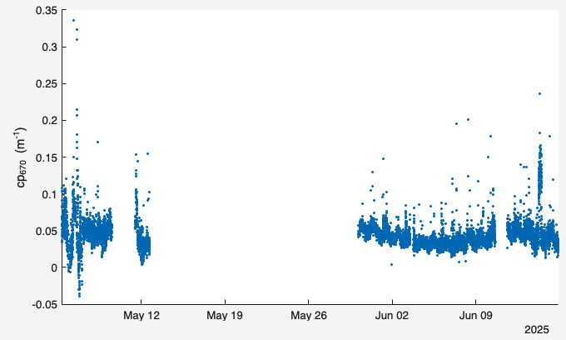

References:
Agrawal, Y. C. and H. C. Pottsmith, 2000. Instruments for particle size and settling velocity observations in sediment transport. Mar. Geol. 168, 89–114.
Boss, E., N. Haëntjens, T. K. Westberry, L. Karp-Boss, and W. H. Slade, 2018. Validation of the particle size distribution obtained with the laser in-situ scattering and transmission (LISST) meter in flow-through mode. Optics Express. DOI: 10.1364/OE.26.011125.
Boss, E., Haëntjens, N., Ackleson, S.G., Balch, B., Chase, A., Dall’Olmo, G., Freeman, S., Liu, Y., Loftin, J., Neary, W., Nelson, N., Novak, M., Slade, W.H., Proctor, C., Tortell, P., Westberry, T.K., 2019. Inherent Optical Property Measurements and Protocols: Best Practices for the Collection and Processing of Ship- Based Underway Flow-Through Optical Data (v4.0). IOCCG Protocol Series 4, 17. http://dx.doi.org/10.25607/OBP-458
Haëntjens, N., and E. Boss. 2020. Inlinino: A modular software data logger for oceanography. Oceanography 33(1):80–84, https://doi.org/10.5670/ oceanog.2020.112.
Slade, W.H., Boss, E., Dall’Olmo, G., Langner, M.R., Loftin, J., Behrenfeld, M.J., Roesler, C., Westberry, T.K., 2010. Underway and Moored Methods for Improving Accuracy in Measurement of Spectral Particulate Absorption and Attenuation. Journal of Atmospheric and Oceanic Technology 27, 1733–1746. https://doi.org/10.1175/2010JTECHO755.1

