Processing BB3 data for Tara Polar Circle

Emmanuel Boss and Alison Chase, University of Maine, Mar 10, 2016

In this document we provide the methodology for processing the Eco-BB3 data.

We used two sensors on the Tara: S/N 349 from OSU (from Lorient to Quebec City and S/N 1093 from LOV (starting in Quebec City).

**Calibration**

Precision bead calibration was done for both sensors after the cruise (for 349 also before the cruise). From these we obtain the slope factors.

Slope factors calibrations tables (WETLabs)- SN 349:

|  |  |  |  |  |
| --- | --- | --- | --- | --- |
| Nominal  /date | 03/12/2012 | 12/12/2012 | 8/19/2015 | Mean+/-stdev using only 2012 |
| 470 | 7.895e-6 | 7.771e-6 | 9.032e-6 | 7.83+/-0.09E-06 |
| 526 | 4.392e-6 | 4.337e-6 | 4.346e-6 | 4.36+/-0.04E-06 |
| 660 | 2.259e-6 | 3.565e-6 | 3.263e-6 | 2.91+/-1.0E-06 |

Slope factors calibrations tables (WETLabs)- SN 1093:

|  |  |  |  |
| --- | --- | --- | --- |
| Nominal  /date | 11/18/2014 | 2/11/2015 | Mean+/-stdev |
| 470 | 6.003e-6 | 5.994e-6 | 6.00+/-0.01E-06 |
| 526 | 3.827e-6 | 3.879e-6 | 3.85+/-0.04E-06 |
| 660 | 2.088e-6 | 1.982e-6 | 2.04+/-0.07E-06 |

Dark offset were determined using a dark tape in the casket at Quebec City:

|  |  |  |  |  |
| --- | --- | --- | --- | --- |
| Nominal  /sensor | SN 349  Median | SN 349  Mean+/-stdev | SN 1093  Median | SN 1093  Mean+/-stdev |
| 470 | 56 | 56.0 +/- 1.6 | 50 | 50.6+/-1.2 |
| 526 | 57 | 56.8+/- 2.3 | 22 | 22.4+/-3.2 |
| 660 | 33 | 36.4+/- 7.4 | 35 | 35.0+/-2.9 |

We process the data as in Dall’Olmo et al., 2009:

bbp()=2  [Slope() (counts()-dark())] bb,salt-water() - bb,wall()

Where the slopes and darks are based on the above tables, bb,salt-water () is the backscattering due to salt water (computed using the TSG data using Zhang et al., 2009 with an assumed depolarization 0.039) and bb,wall() the contribution of the casket to the signal as determined by Dall’Olmo et al., 2009 (bb,wall()=0.046 E-03, bb,wall()=0.03 E-03) and assuming bb,wall()=0.02 E-05.

In the data set we only provide to values of total particulate backscattering, when the water was not routed through the filter.

Quality control was assessed by computing the particulate backscattering ratio at three wavelengths (see figure below). Values were nearly constant spectrally and the median values were near 0.01 (Whitmire et al, 2009, Westberry et al., 2010).

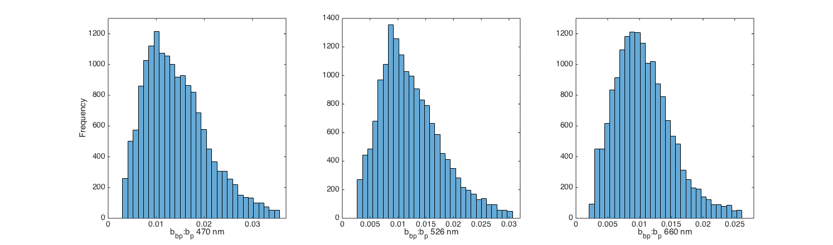

References:

Dall'Olmo, G., T.K. Westberry, M.J. Behrenfeld, E. Boss, and W.H. Slade, 2009. Significant contribution of large particles to optical backscattering in the open ocean. Biogeosciences 6, 947-967.

Westberry, T.K, G. Dall'Olmo, E. Boss, M.J. Behrenfeld, and T. Moutin, 2010. Coherence of particulate beam attenuation and backscattering coefficients in diverse open ocean environments. Opt. Express Vol. 18, No. 15, 15419-15425.

Whitmire, A.L., E. Boss, T.J. Cowles, and W.S. Pegau, 2007. Spectral variability of the particulate backscattering ratio. Optics Express, Vol. 15, No. 11, pp. 7019-7031.

Zhang, X. Lianbo Hu, and Ming-Xia He, Scattering by pure seawater: Effect of salinity, Optics Express, 2009, 17(7), 5698-5710.