Welcome to the amazing world of Scanning logsheets
From doug on the 20220221 from the south of the American continent

- Take the scanner in the white cupboard in the library. It is in a bag with its cables.
- Connect it to the science computer.
- Open the software “Capture on touch”.
- The scan is made per station for event, and then for samples.
- Update the name of the file : click on the pen.
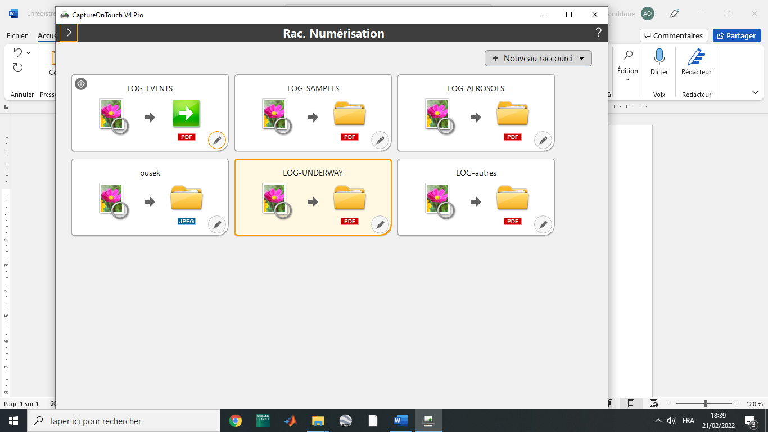
- Go to “sortie1”.
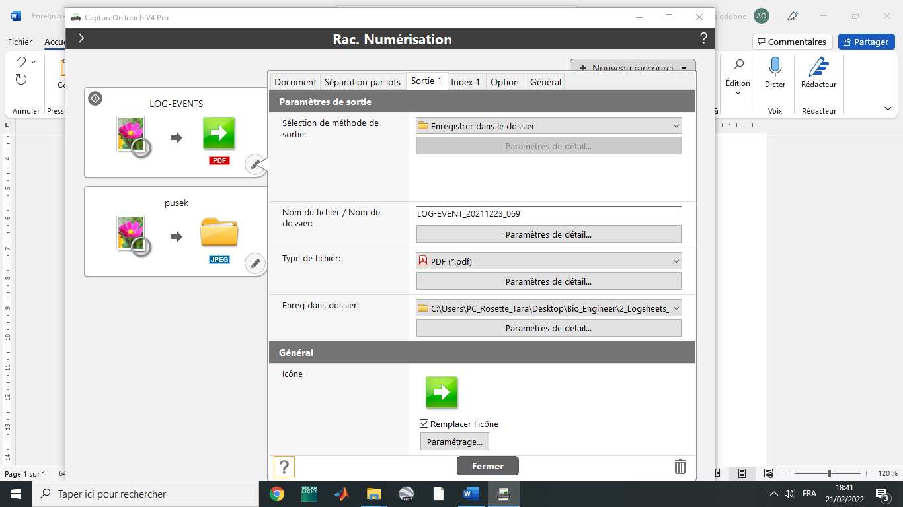

- Update the name of the file in this format : “LOG-EVENT_YYYYMMDD_STATION”
For example for the station 069 on the 23rd of November 2021:
LOG-EVENT_20211123_069
- Click on “Fermer”.
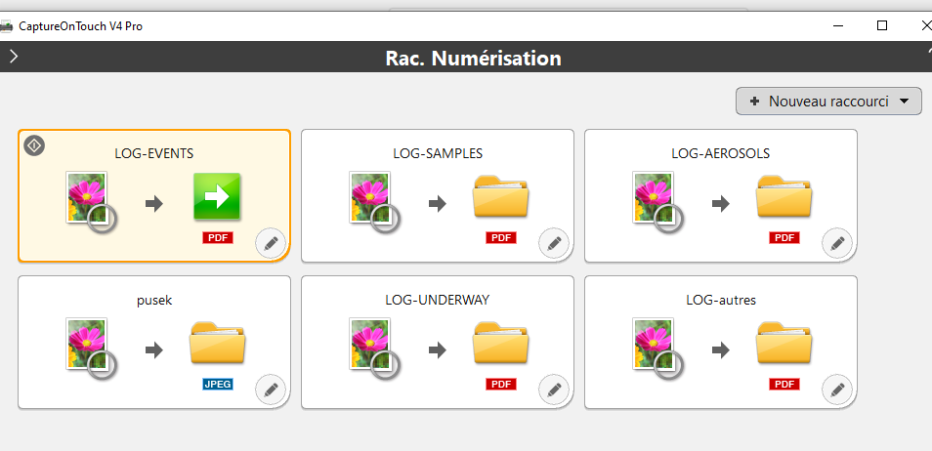
- Put the whole events of the station in the scanner. Organise them chronologically, and upside down, the first page looking at the back of the scanner.
- Click on the green arrow.
- This page opens up while it is scanning all the documents.

- At the end of the process, CLIK ON “TERMINER”, otherwise nothing is saved !!
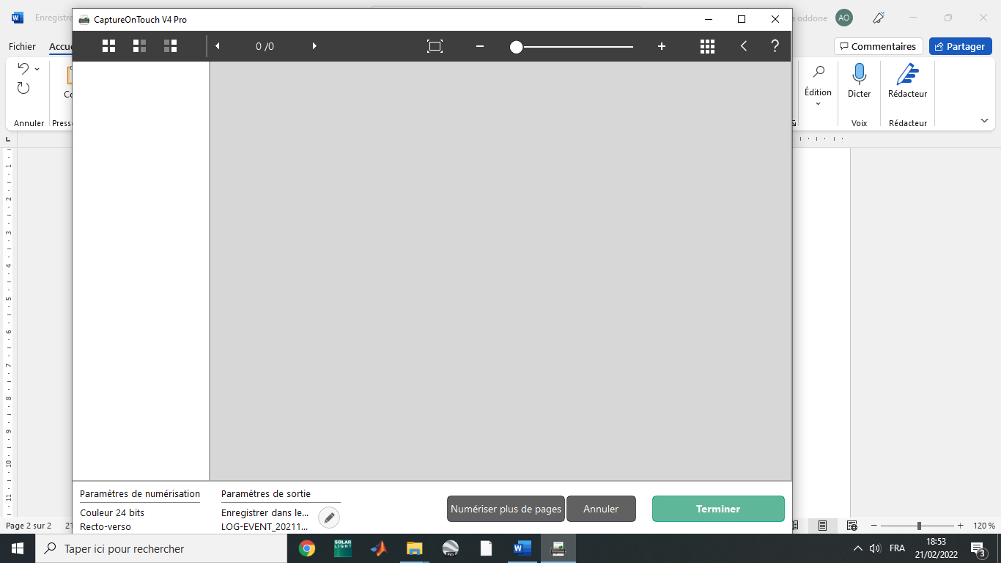
It is saved in the folder”bio_engineer”, “logsheets”, “sanned logsheets”. Make sure to make a back up of the logsheets on the NAS (ask the oceano engineer for help).

- Repeat the steps 5 to 10 for the event per station, and for the samples per station. Also, you use the “underway” and “aerosol” type for scanning these logsheets.
- Thanks !

