Welcome to the amazing world of Scanning logsheets

From doug on the 20220221 from the south of the American continent

1. Take the scanner in the white cupboard in the library. It is in a bag with its cables.
2. Connect it to the science computer.
3. Open the software “Capture on touch”.
4. The scan is made per station for event, and then for samples.
5. Update the name of the file : click on the pen.

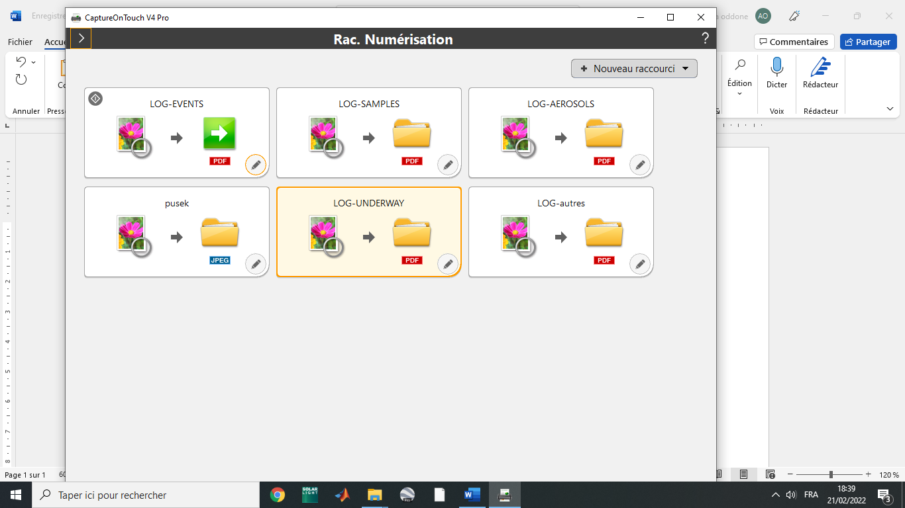

1. Go to “sortie1”.

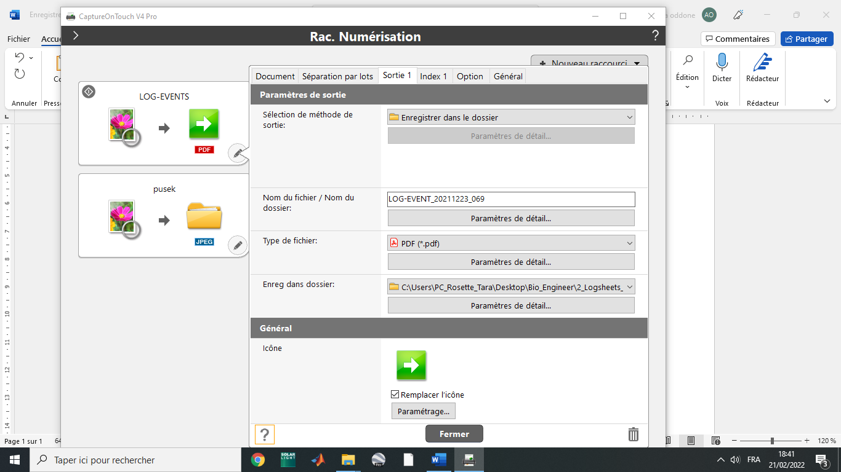

1. Update the name of the file in this format : “LOG-EVENT_YYYYMMDD_STATION”

For example for the station 069 on the 23rd of November 2021:

LOG-EVENT_20211123_069

1. Click on “Fermer”.
2. 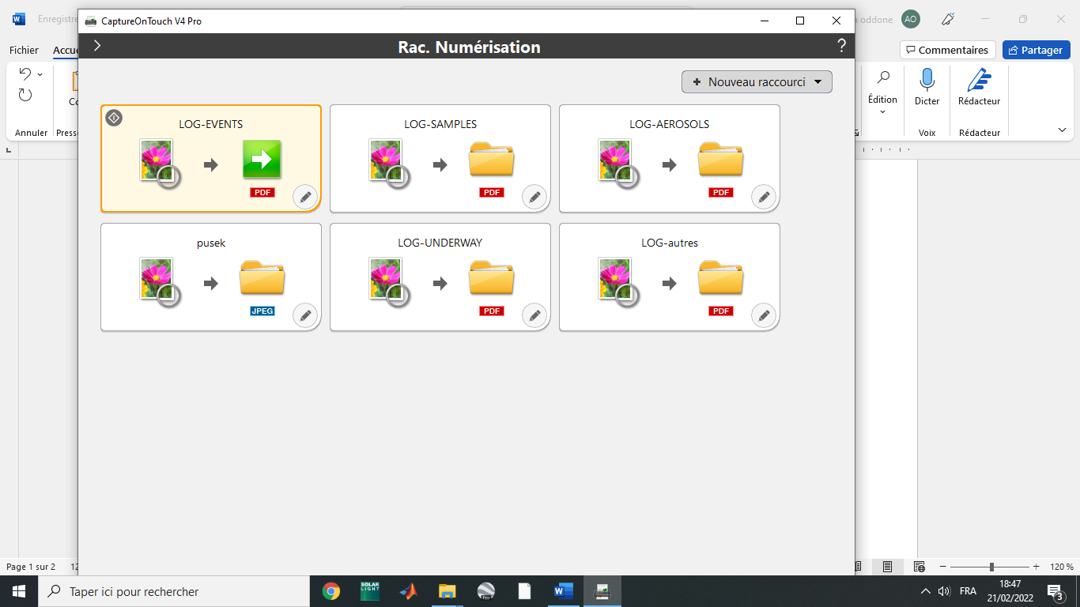Put the whole events of the station in the scanner. Organise them chronologically, and upside down, the first page looking at the back of the scanner.
3. Click on the green arrow.
4. This page opens up while it is scanning all the documents.
5. At the end of the process, CLIK ON “TERMINER”, otherwise nothing is saved !!

It is saved in the folder”bio_engineer”, “logsheets”, “sanned logsheets”. Make sure to make a back up of the logsheets on the NAS (ask the oceano engineer for help).

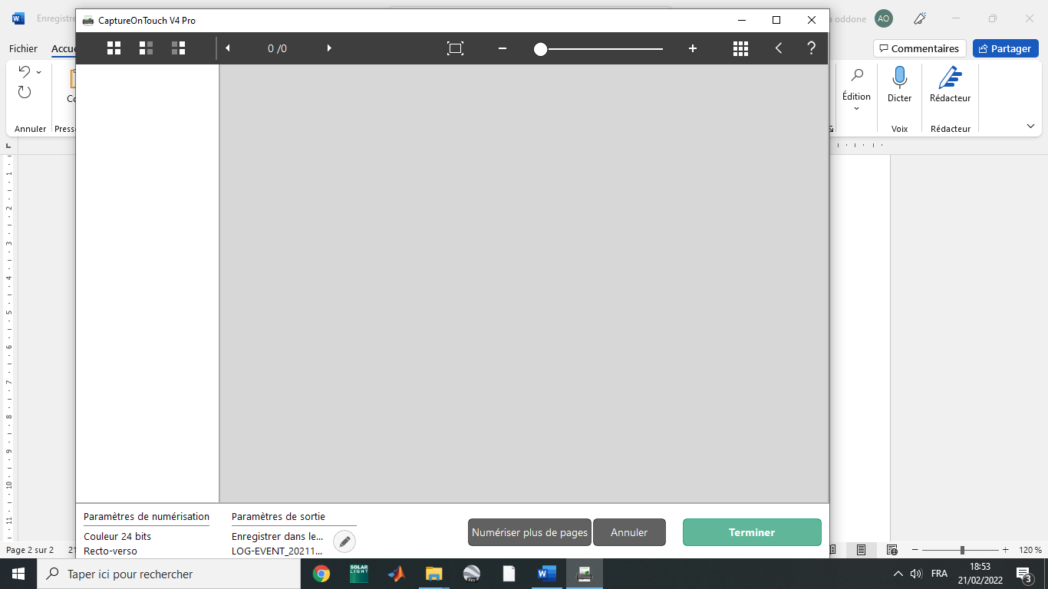

1. Repeat the steps 5 to 10 for the event per station, and for the samples per station. Also, you use the “underway” and “aerosol” type for scanning these logsheets.
2. Thanks !