Tips for operator C

Autors :

* Julie Poulain (Lorient-Ostende)
* …

**Day before the station**

* Prepare the logsheets, labels, tubes
* 2 racks with location of tubes are ready to use for 4 stations, in the wetlab
* Few tubes are available in a grey box in the wetlab, near the peristaltic pump. If not enough, the stock is in the forepeak.

**Starting the station**

* In the atelier, if not yet done switch ON the circuit-breaker of the wetlab on electric board
* In the wetlab, prepare all the tripods
  + Humidify the blue filter holders using spray of MQW and place Dacron pads
  + Humidify the Dacron pads using spray of MQW and place the right filters
  + Close all the tripods
* Outside the wetlab,
  + Place the funel equiped with 20 µm mesh on the dedicated holder. Attach using elastic a piece of 200 µm mesh on the outlet of the tube connected to pump A20. Then attach the weight on the inlet of the tube. Dip the tube inlet to the surface sea water (~1m)
  + Start the pump A20 (switch O/I in the wetlab) and rinse all carboys using FSW. The pipe of the Filter Sea Water < 0,1 µm is on the right of the wetlab and the swith is located on the aft deck, port side
* In the same time as the Rosette is deployed :
  + Start the filling of carboys
  + Fill the logsheet event in the « timonnerie »

Example for a NORMAL SITE :

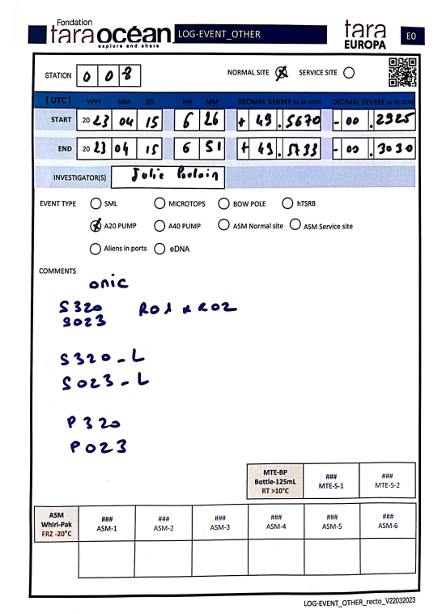

Example for a SERVICE SITE :

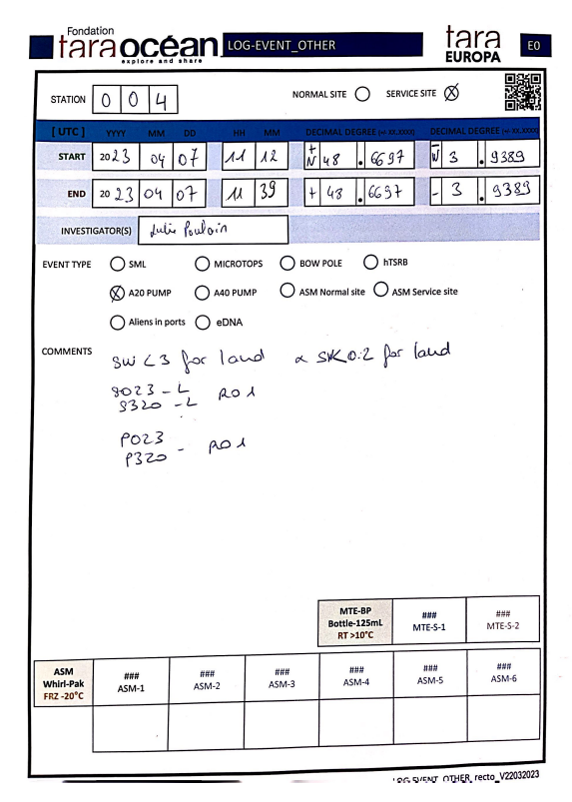 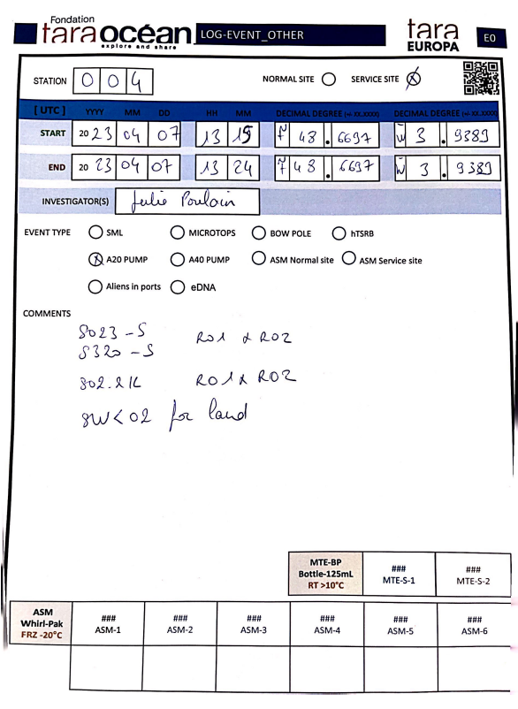

* When the first carboy is full, go to the next one and start the filtration immediately (Cf Handbook), launch the timer and the debimeter.
* Process in the same way for the next full carboy

**During the station**

* Keep always an eye on carboys and tripods
* If air is present don’t hesitate to use the bleeding valves
* If there are leaks around or under the tripode, stop the filtration by releasing the hose from the head and resolve it. The reasons can be various. Incorrectly tightened throttles, jaws or clamps. Damaged O-ring, filter support and/or grille badly positioned. After some time of filtration it can be due to the saturation of the filter. In this case you may have to decide to stop the filtration before reaching the set time or volume.

All stuff and spare for repration are in the black and red case in the wetlab

* Fill the logsheet with filtered volume, time of filtration and any comments (at the back of the logsheet) if something have running wrong.
* In the case of highly contaminated water that quickly saturates the filters. Stop filtering before the end of the allotted time. For the long read protocols (S320-L and S023-L) change the filters and place the second filter in the same tube as the first one by adding a little more Nucleoprotect.

**Endding the station**

* Store S320-L/S023-L and S<02-R01 and R02 in the forepeak freezer and fridge respectively
* Clean all the tripods and carboys and let dried (tripode opened)
* Fill the MQW tank (it’s not recommanded to do that at the begining or during the station)
* Prepare new bleach solution (10%) for the next station
* Check your logsheets (Events and Samples) and store them in the folder « Logsheets to scan »
* Fill the TaraEuropa_Samples_Inventory_Shipping file <https://docs.google.com/spreadsheets/d/180Bqgv3TUK45k79oEUiC7QQH7Rejp2MMH_K1KHyq_nc/edit#gid=0>

**SO22K Stop before saturation**

* Mesure time filtration L per L using the 1L graduated cylinder

