Procedure to change ALFA Chlorophyll conversion coefficients
- Start and run the ALFA software as you normally would.
- Towards the lower left of the software panel/screen (below the green spectral plot), there is a button set to “Meas. Prot.” by default.
- Move the mouse cursor over to the button and click on it. The button will now display several options via a drop down menu type feature. Select “Chl Calc” (it should be the 4th option listed, top to bottom).
- You should notice in the middle of the screen (below the green PDP plot) where several buttons were, has changed to several display indicators with numbers. See the screen capture below:
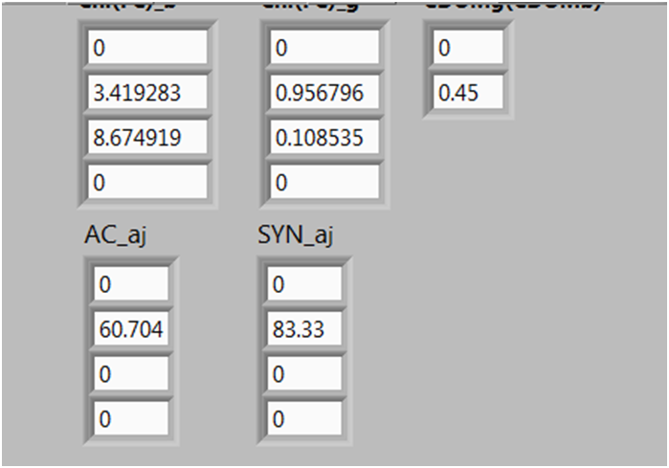
- The indicator windows on your computer may be cut off like in the above capture. The top left window above is for the blue Chlorophyll measurement (circled in blue, above the “AC_aj” indicators) and the window for the green Chlorophyll measurement is to the right of the blue indicators (circled in green, above the “SYN_aj” indicators).
- The goal here is to change these numbers shown, to give a better real-time Chlorophyll conversion for the ALFA instrument. This will have to be done each time the software is exited completely and re-opened (i.e. after a computer reboot or closing the software (i.e. via the “X button”) and re-starting). Unfortunately since a Labview executable is being used, these numbers cannot be saved by a user, only set and saved at the time of the executable’s creation.
- To change the numbers, you can simply highlight and type over what is present. After typing each new number, click outside of the window to set it or hit the Enter button on the keyboard.
- Under the blue conversion we would like to first change the “3.419283” number to “2.46”. The second change would be to make “8.674919” to “0”.
- Under the green conversion we would first like to change “0.956796” to “0.469” and the second change would be “0.108535” to “0”.

- After the changes, the indicators would look like this:
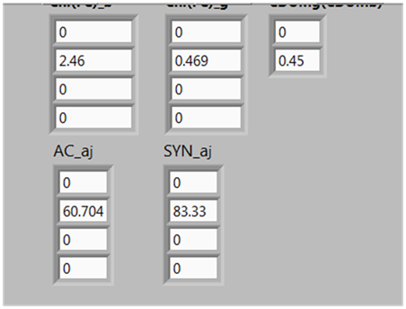
- Again, these changes are in an effort to provide a better Chlorophyll conversion in the areas where the ALFA will be used during the TARA cruise. As mentioned previously, these will have to be changed each time the software is exited completely and re-opened (i.e. after a computer reboot or closing the software (i.e. via the “X button”) and re-starting).
- After the numbers are changed, you can click on the same drop down to change “Chl Calc” back to “Meas. Prot.” or whatever you had set previously.
- If for some reason the numbers don’t get changed, this conversion can always be done after the data is saved, just try to make note of it. Changing the numbers will provide a (hopefully) better real-time assessment of the Chlorophyll concentration.

