TARA TSG Calibration condition check Step by step @ Josep Mª/EMS)

This document aims to guide the Oceano Engineer to perform an evaluation of the TSG conductivity cell calibration condition. To check the real TSG calibration condition the conductivity cell must be completely clean and dry. Nevertheless, it is a good experiment to go through the following protocol before and after cleaning the TSG, so we can see if the biofouling was affecting the conductivity data or not. Please, follow the next steps:

1. Be sure the TSG is completely clean and dry.
2. Power on the NMEA Interface Box to supply power to the TSG. (Inlinino data acquisition software must be closed).
3. Open the Seaterm software on the Underway computer. It should be already installed.



1. Go to the *Configure* tab and Select *SBE 45 TSG…*
2. Select COM Port and Baud Rate (normally should be 9600). Press Ok when finished.

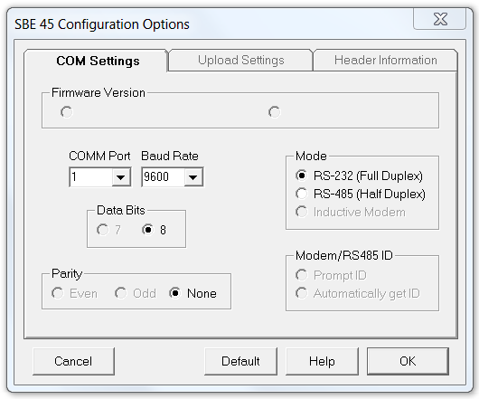

1. Press the *Connect* Icon.
2. Now if communication is established you will see a screen similar to this one:

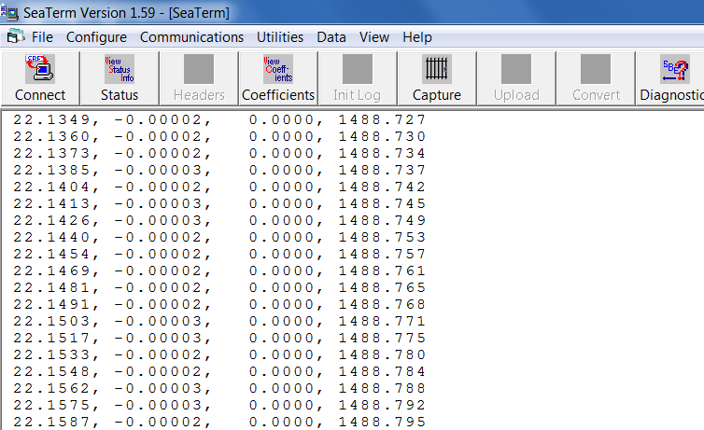

You should see this data being update each 10 sec.

1. Click on the command window and press enter several times until you get a prompt (S>):

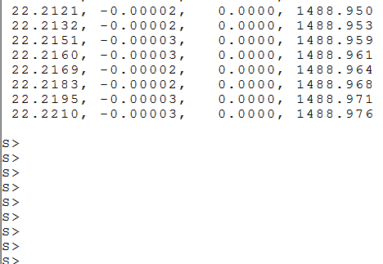

1. Very quick, after the last step, type *Stop* and press enter to stop the data acquisition.

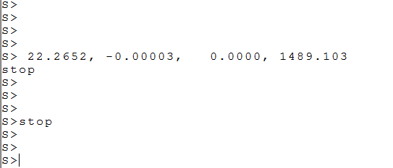

1. Type *Connect45* and press enter to communicate directly to the TSG and not to the NMEA box.
2. Now you should have direct communication with the TSG and you can send commands straightforward.
3. Press the icon Capture to start capturing all the following steps in a file.

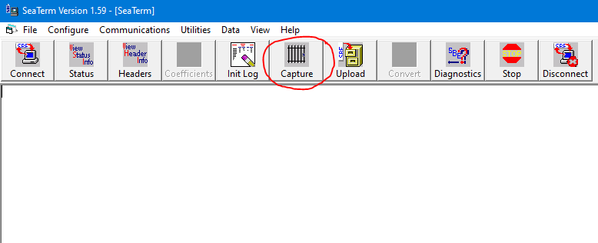

1. Send the command ds to see the TSG configuration (your conf might different from the example below).

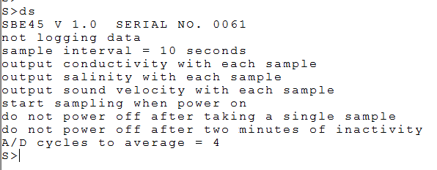

1. Send the command TCR to get the raw conductivity value from TSG. Be sure you are capturing the info displayed in a file (very important).

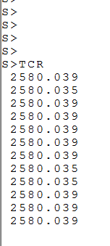

1. Send the command TC to get the converted conductivity value from TSG.

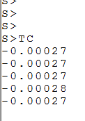

1. Stop capturing by pressing again to the Capture icon.
2. Disconnect the TSG from the software by pressing the disconnect icon.
3. Power off the TSG by switching off the NMEA Interface box.
4. Use the TSG Calibration Report Template (TSG_snxxxx_CAL_EVAL_TEMPLATE_LEGX.docx) to generate the Official Report and send it to the scientific people on shore and to EMS via email.

Thanks. Josep Mª Erta /EMS