TARA TSG SN: 0269 Conductivity cell condition report after LEG5 @ Josep Mª Erta/EMS

The aim of this report is to evaluate the conductivity cell condition of the TSG with serial number 0269 after 22 days of operation. The operation time corresponds to the LEG5 duration of Mission Microbiomes (Martinique-Macapa).

The TSG was initially installed on August 2021 in the Underway System of TARA research sailing boat in Martinique.

It has been in continuous operation from the 18th of August to the date when this evaluation was done. The evaluation was done the 8th of September 2021.

The conductivity cell was cleaned three times during the navigation. The sensor was rinsed thoroughly with Triton-X, bleach and DI water each time but the end caps were not removed due to the risk of breaking the conductivity cell because of the ship heave.

An additional cleaning was done in the end of the LEG5 once in Macapa. There the sensor was fully cleaned and the end caps were removed to do a proper clean of the TSG chamber (removed or not removed).

The graph below shows the dates when each cleaning was done:

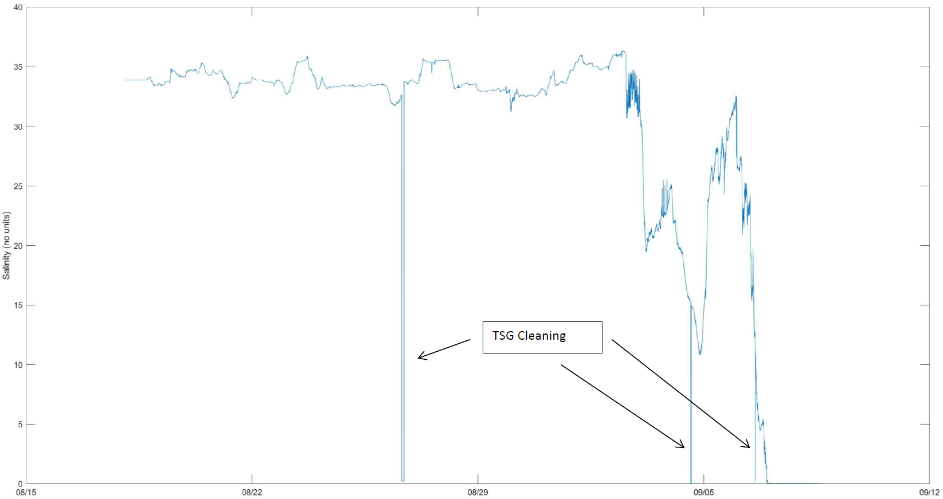

TSG cleaning during LEG5 navigation

TSG cleaning in Macapa

Fig 1. Salinity Time Series graph. Spikes where the salinity becomes 0 correspond to cleaning episodes.

Every conductivity cell has a calibration certificate. The calibration certificate contains information of the frequency output for zero conductivity, obtained from a clean and dry cell. A zero conductivity frequency that has changed by more than a few 10ths of a Hertz may indicate a cell that is damaged or considerably out of calibration. The frequencies obtained after LEG5 from the TSG serial number 0269 with the conductivity cell dry were:

*Take the screenshot below from the capture you generated during the TSG CAL CHECK protocol (see TSG CAL CHECK SEP By STEP document).

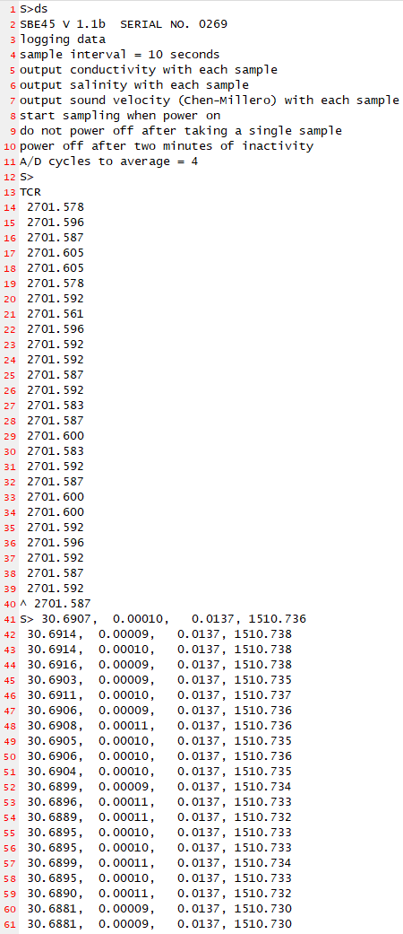

Fig 2. Conductivity raw frequencies obtained from the TSG sn 0269 after LEG5 with the conductivity cell cleaned and dry.

On the other side, the last conductivity calibration certificate of the TSG sn 0269 is the following:

*Take the screenshot below from the calibration certificate saved in the Underway computer, ask for it to EMS if you do not find it. 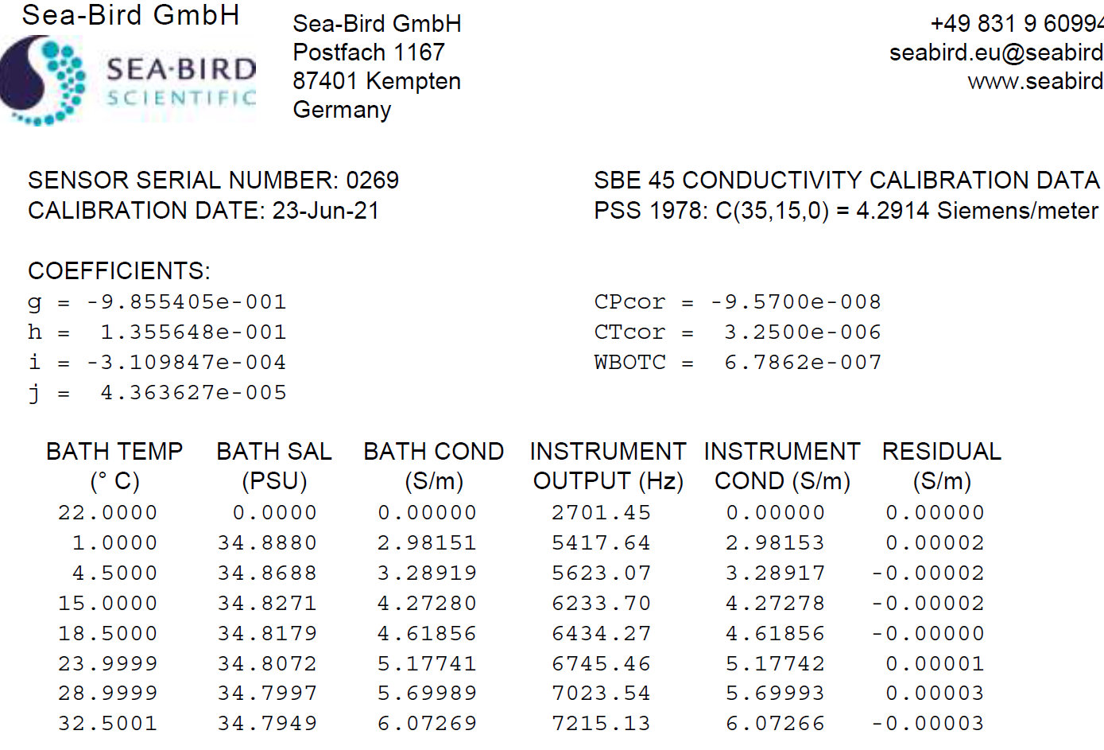

Fig 3. TSG sm 0269 last conductivity calibration certificate.

The calibration sheet shows a zero frequency of 2701.45 Hz whereas the value obtained during the sensor evaluation after LEG5 was in average 2701.59 Hz. We can affirm that the zero frequency output has not change more than few 10ths. **Thus, we can conclude the calibration condition of the conductivity cell of the TSG 0269 to date 09/09/21 is acceptable (Change conclusion depending of the results found).**

Josep Mª Erta/EMS

Tara Oceano Engineer LEG5