Table of Contents

1. Light Scattering Sensor Installation 1
1.1 Light Scattering Sensor Wiring 1
2. Operation 3
2.1 Light Scattering Sensor Care 3
3. Description 4
4. Specifications 6
5. Calibration 7
5.1 Optical Measurements of Suspended Particles in Water 8
5.2 Calibration Stability 10

1. Light Scattering Sensor Installation
The LSS is designed to measure light scattering from particles in the forward hemisphere relative to the front surface of the sensor. The sensor should be installed at the outermost diameter of the user’s system. This should be done such that all light scattering objects will be behind the plane defined by the front surface of the LSS (Figure 1). The LSS should also be placed as far away from light reflective objects as possible. If significant zero offset is observed in the LSS data for very clean water, the LSS is probably not mounted correctly.
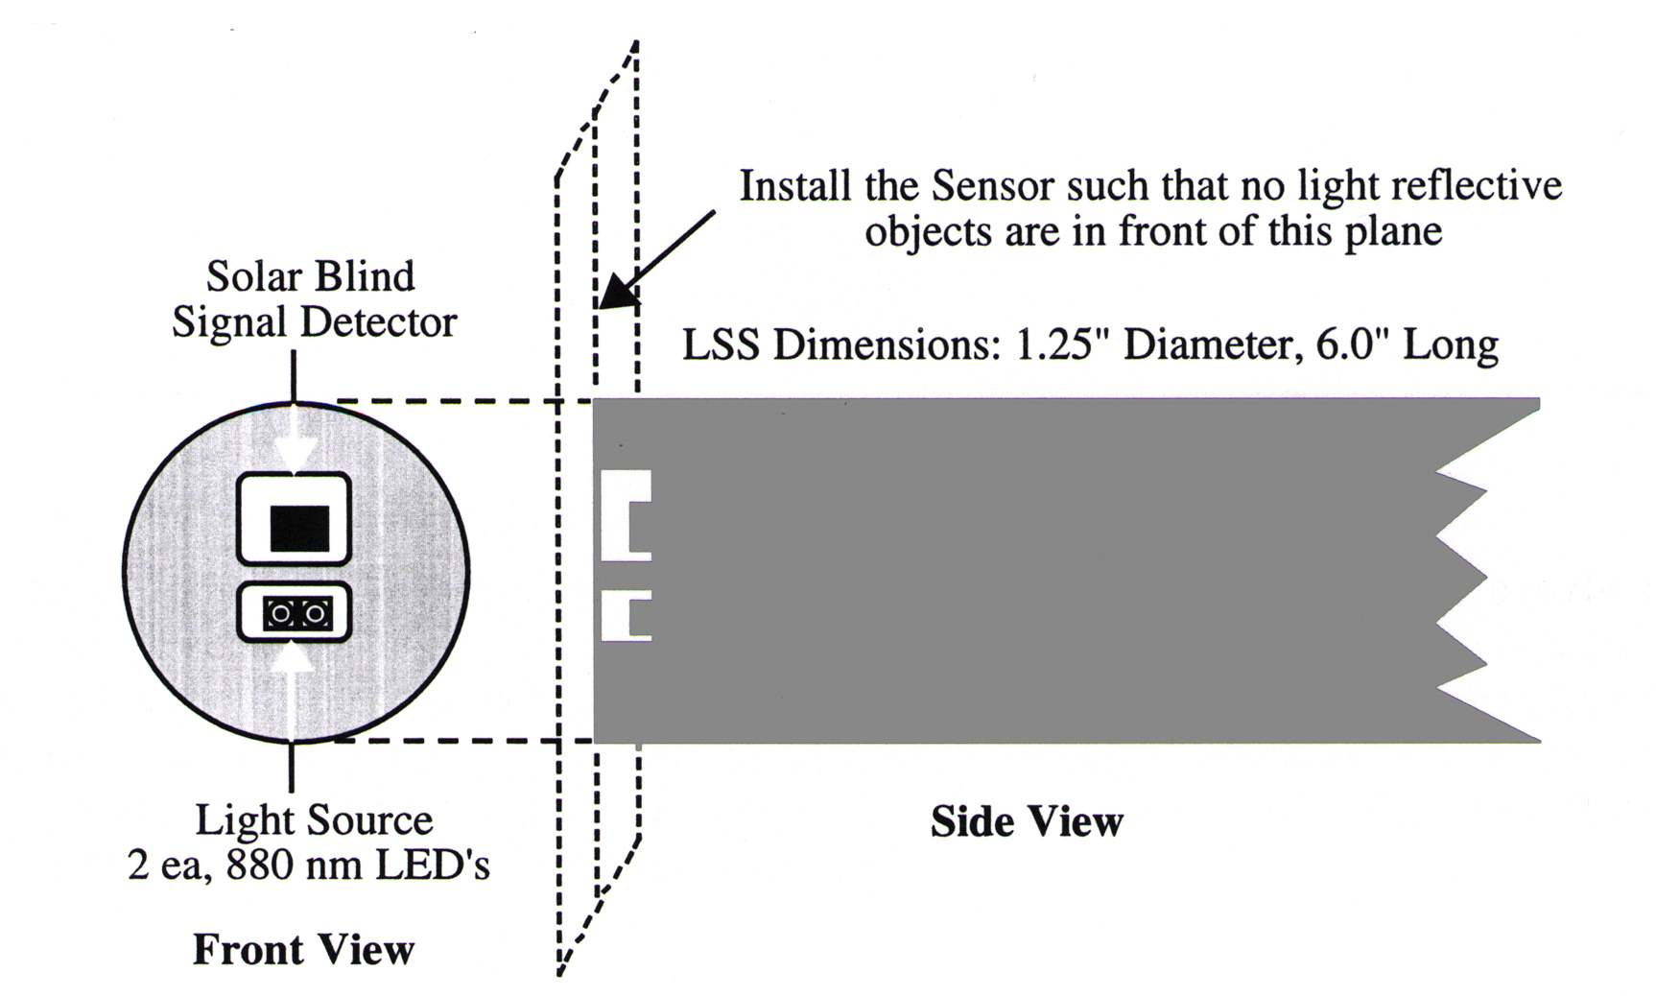
Figure 1. LSS Installation Diagram

1.1 Light Scattering Sensor Wiring
Do not remove the protective cap during installation and wiring of the LSS. The protective cap will prevent accidental damage to the sensor surface and can be used to test the device during the installation and wiring process. The cap is designed to allow reflected light to be measured permitting sensor operation to be verified with the protective cap in place.

The sensor is supplied with a five-conductor bulkhead connector. The five-conductor interconnecting cable should be connected to the user’s system (Figure 2). The LSS should be operated with a power supply capable of delivering 50 milliamps of current at nominally +12 VDC. The sensor voltage output is 0 to +5 VDC with an output impedance of 1000 ohms. The sensor has two gain ranges, high and low. For the user who chooses to select gain manually, high gain is selected by leaving pin 3 open. Low gain is selected by connecting pin 3 to power ground. (Gain can be remotely controlled by the user’s equipment. Pin 3 is tied to +V, through a 100K-ohm pull-up resistor permitting a logic high to select high gain and a logic low to select low gain.) Gain can also be controlled manually if a special cable is fabricated (contact WET Labs for details).

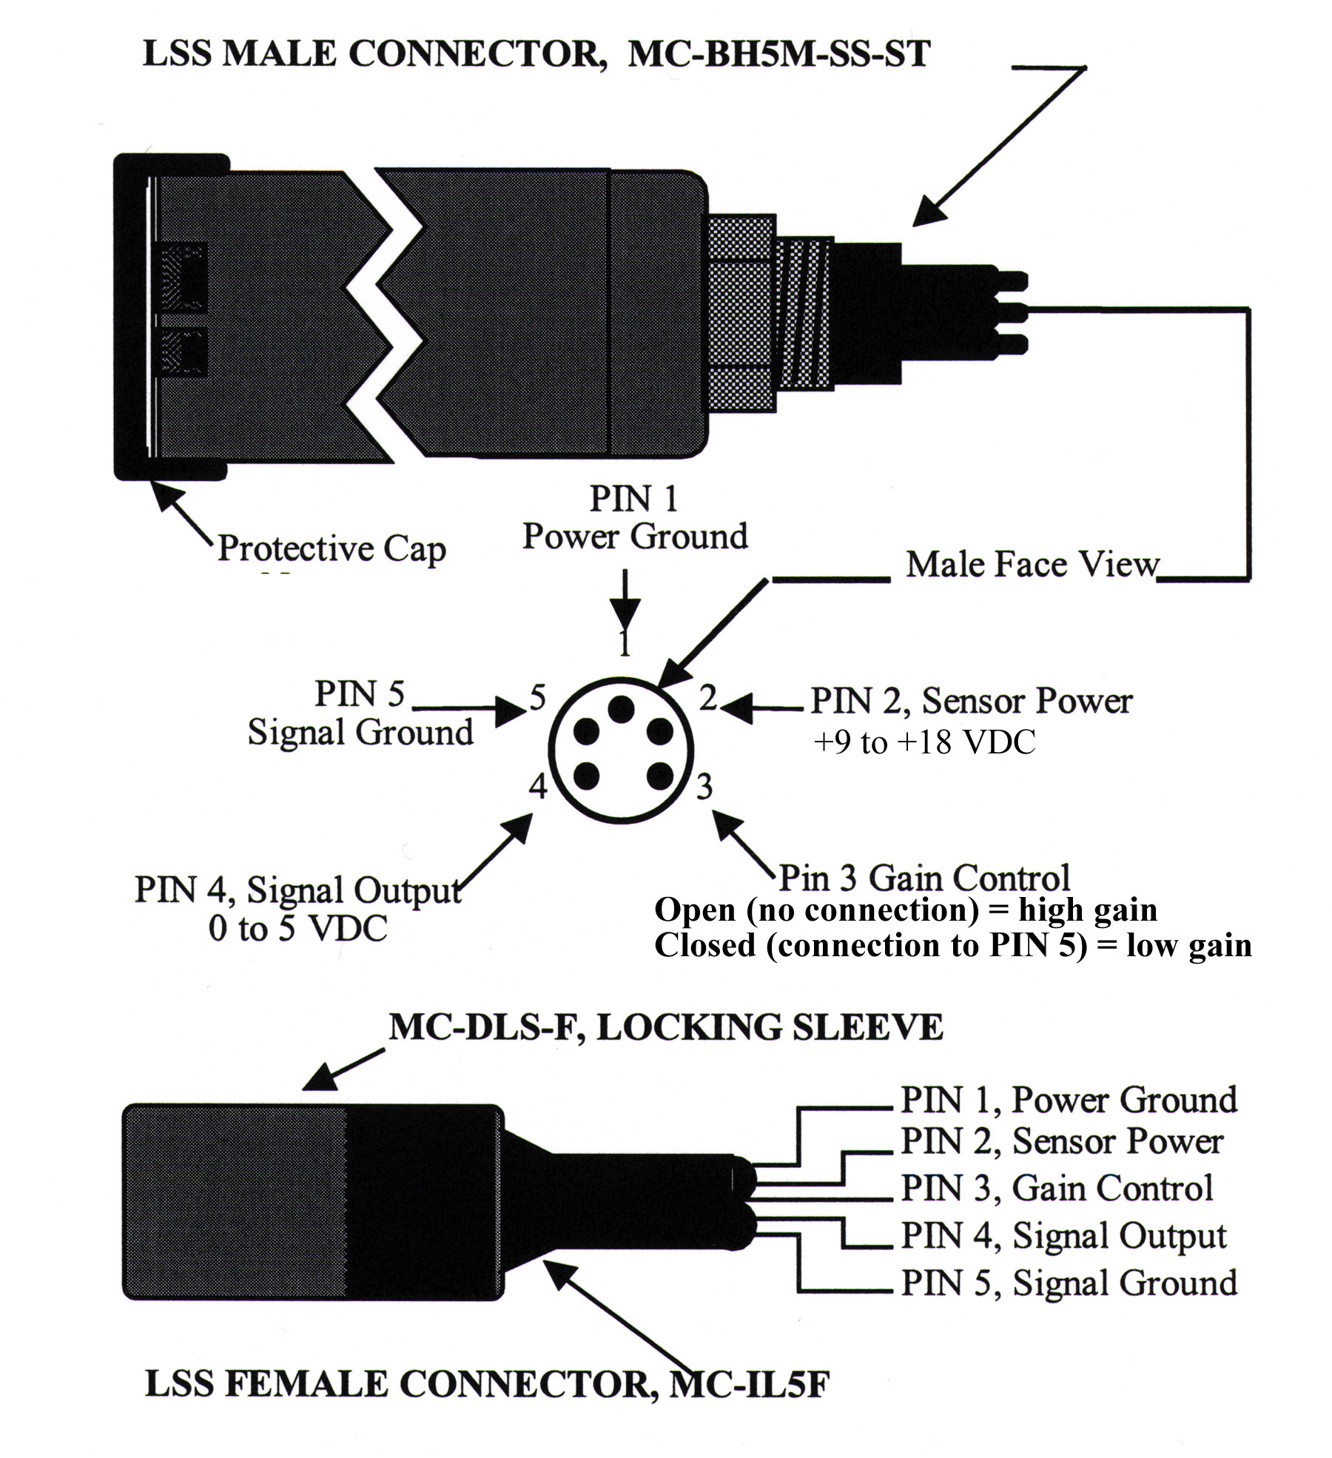

Figure 2. LSS Connectors

2. Operation
- Measure the LSS power supply voltage and make sure the voltage is between +9 and +18 VDC.
- Measure the LSS current drain. It should be less than 20 mA DC (1x units) or 24 mA DC (3x units). Refer to individual calibration sheets for other units.
- Remove the LSS protective cap and block the LSS solar blind signal detector using black electrical tape, then measure the LSS zero output. The voltage should be near zero, less than 10 mV DC, or at factory values. The sensor RMS electrical noise should be less than 0.01 percent of full scale voltage. Gently clean the head with alcohol afterward to remove any residual adhesive.
- Remove the black tape from the sensor and verify that the sensor output varies with reflectance from objects in the sensing volume. In air the sensor detector can be easily saturated by ambient light and the output will either not change or be negative or both. This is not a problem in water greater than 1 meter in depth. The LSS output will generally go to full scale, approximately 5.5 VDC if you cup your hand in front of the sensor to block ambient light. The LSS is very sensitive in air and will have significant output due to the reflection of light from surrounding objects and/or ambient light.

2.1 Light Scattering Sensor Care
The LSS housing material is ABS plastic filled with black epoxy and the optical windows are clear epoxy. The LSS sensor surface may be cleaned with soap and water or alcohol. Use a non-abrasive paper or cloth to clean the sensor front surface to avoid scratching the clear epoxy windows. Clean the optical windows before and after use in water. Be sure to place the protective cap on the instrument when not in use.

3. Description
The Light Scattering Sensor (LSS) measures light scattered from suspended particles in water. This measurement is often referred to as turbidity, but is also a measure of water clarity, visibility and particle concentration. The basic scattering sensor design is capable of linearly measuring nearly all turbidities found in natural waters from 0.0005 NTU to 750 NTU. WET Labs produces four different models of LSS to cover various sub-ranges of this range.
The optical design of the LSS is shown in Figure 3. The optical sensor consists of two 880 nm wavelength light sources and a solar-blind light detector mounted in adjacent cavities where the mutual cavity wall forms a light stop between the light source and the light detector. The light stop is used to block the direct transmission of light from the light source to the light detector such that only scattered light is measured. Light source and light detector cavities are filled with clear epoxy to form an optically clear, watertight window. Depths of the cavities are such that the light transmitted from the LED’s and the scattered light received by the detector are maximized.
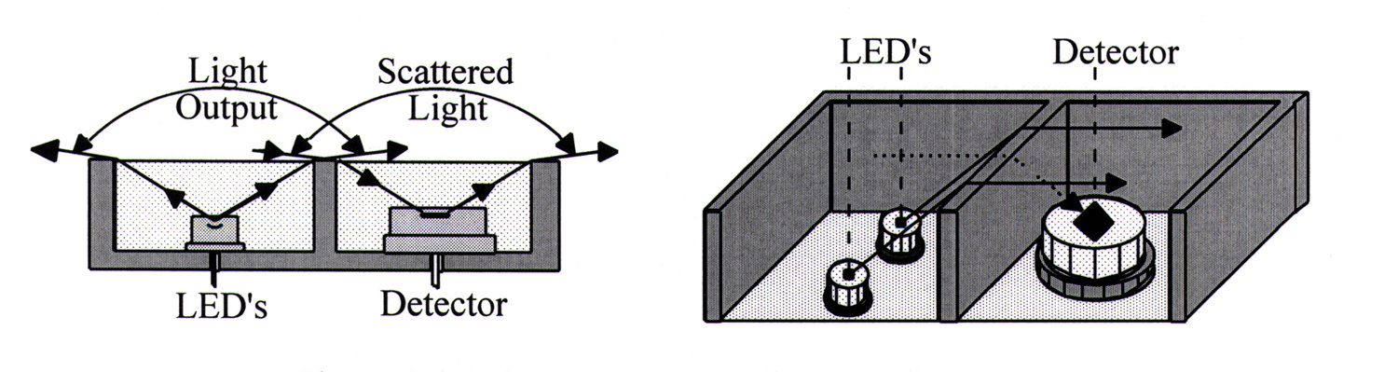
Figure 3. Dual light source and detector geometry
Light transmitted by the LED is refracted at the sensor surface to radiate over the entire hemisphere. Similarly, light scattered from particles is received from the entire hemisphere. The directional sensitivity within this hemisphere is approximately as the cosine of the angle from zenith. For this reason, the sensor needs to be mounted at the periphery of the package such that no reflective objects are in the forward hemisphere.
The refraction described above allows scattering at almost all angles to be detected by the sensor. The signal received by the sensor is proportional to:
$\int_{0}^{π}{β\left(θ\right)}w\left(θ\right)\text{sin}\left(θ\right)dθ$, where β(θ) is the Volume Scattering Function, and w(θ) is a weighting function determined by optical modeling of the sensor design to be as shown in Figure 4. Maximum sensitivity is for scattering angles near 100 degrees.

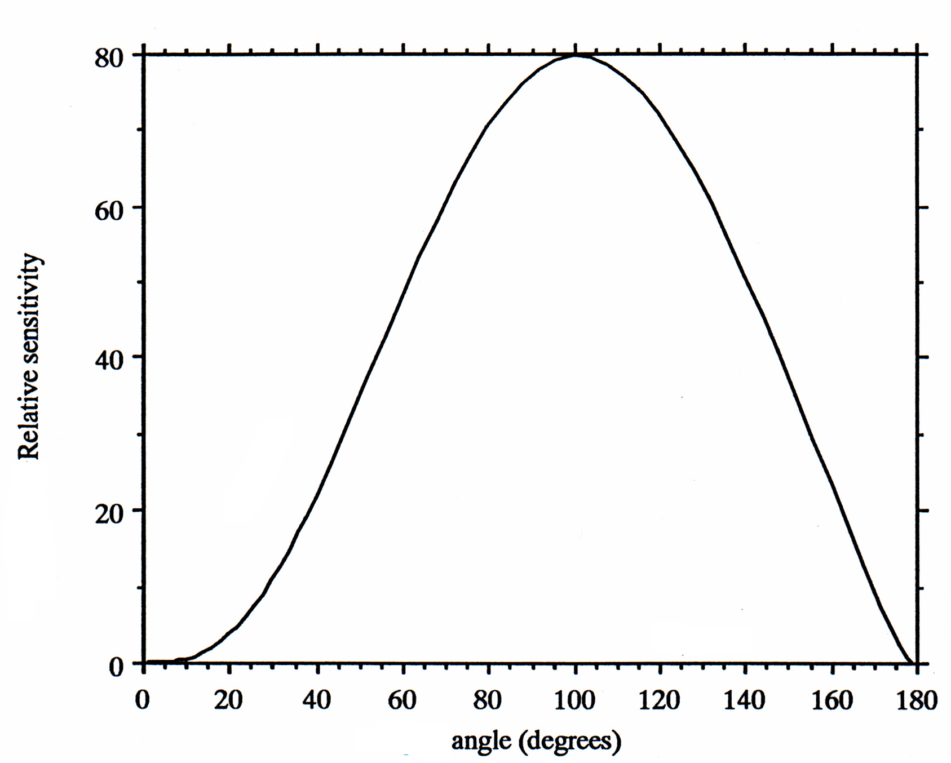
Figure 4. LSS response in water
Each model of LSS has two ranges selected by setting a fifth conductor to open or ground. For instance, our standard model has nominal ranges of 0.0075–25 NTU on low gain and 0.0025–7.5 NTU on high gain. These two ranges cover almost all open ocean and coastal waters. The ratio between the two ranges is always about 3.33. Our 3x sensitive model similarly has nominal ranges of 0.0025–7.5 NTU and 0.0007–2.25 NTU for very clear waters. We also have 1/10x and 1/30x models to cover more turbid inland waters
The sample volume of the LSS varies with the turbidity of the water. The volume is limited by the rapid attenuation of the infrared light by water. In clear waters, roughly 50 percent of the signal would originate from particles less than 11 cm from the sensor face, 90 percent would be from within 40 cm and 99.75 percent from within one meter from the sensor face. In more turbid waters, all those ranges would be shortened. This applies to homogeneous distributions of particles. If there is a large reflective item out front, it could overwhelm the signal from the particles. We recommend at least two meters clear space in front of the LSS in clear waters.

4. Specifications
Measured Parameters Turbidity and suspended solids

Mechanical
Size length: 5 in (12.7 cm)
diameter: 1.25 in (3.2 cm)
Weight in air: 0.57 lbs (0.26 kg)
in water: 0.29 lbs (0.13 kg)
Housing material ABS plastic housing filled with epoxy
Window material clear optical epoxy
Rated Depth 6000 meters

Electrical
Power 9–18 VDC ~20 mA
Signal Output 0–5 VDC
Temperature Stability ~ 0.5%, 0–50 deg C
Power Supply 1x units: 9–18 VDC @ 20 mA;
3x units: 9–18 VDC @ 24 mA
Power Consumption ~200 mW
Sensor Output 0–5 VDC
Response Time 1/10th second

Optical

Resolution < 0.03% full scale
Measurement Range
1x unit ~ 7.5 NTU on high gain; ~ 25 NTU on low gain
3x unit ~ 2.25 NTU on high gain; ~ 7.5 NTU on low gain
Sample Volume Varies. Large for clean water; small for turbid water

Specifications are subject to change without notice.

5. Calibration
Figure 5 shows typical correlations that can be expected in natural waters when the LSS output is compared with beam attenuation, “c,” measured with the 650 nm, 25 cm pathlength Sea Tech transmissometer. The data shows that the LSS output depends on the nature of the particles suspended in the water. The LSS output, like all sensor outputs used to measure inherent and apparent optical properties, will be dependent on particle size distribution, particle shape, index of refraction, organic vs. inorganic ratio, wavelength of the measurement, etc.

Based on these limitations, calibration of the LSS from a scientific perspective implies that the LSS should be calibrated with the particulate material characteristics of the study region since the LSS output is a function of the nature of the suspended particles. Calibration of the LSS from an engineering perspective is less demanding. A light scattering standard that is stable and repeatable such as Formazin can be used to calibrate the LSS and is recommended since this material is readily available and has been used in the past to calibrate light scattering instruments that measure turbidity. Calibrated using Formazin, the LSS output will be a linear measure of suspended particle concentrations in water. The relationship between light attenuation and light scattering from Formazin, clay and organic material is shown in Figure 4. This relationship is approximate and can be expected to vary depending on the nature of the particulate matter suspended in the water column.

The standard 1x LSS is calibrated at the factory using a 5 NTU concentration of Formazin in 16 liters of particle-free water. Particle-free water for calibration purposes can be made by filtering water with a 0.2-micron filter. The calibration water container used at the factory is a 5-gallon black bucket. The LSS is immersed in the water to a depth of approximately 2 inches and centered in the top of the black bucket. Refer to your instrument’s calibration sheet for the output of the LSS for a 5 NTU concentration of Formazin.

The 3x sensitive LSS is calibrated at the factory using a 1.0 NTU solution of Formazin so that the high-gain range will produce an on-scale reading. The calibration of the high-gain range can also be computed from the low-gain calibration and the ratio of the gray-scale card readings for the two ranges.

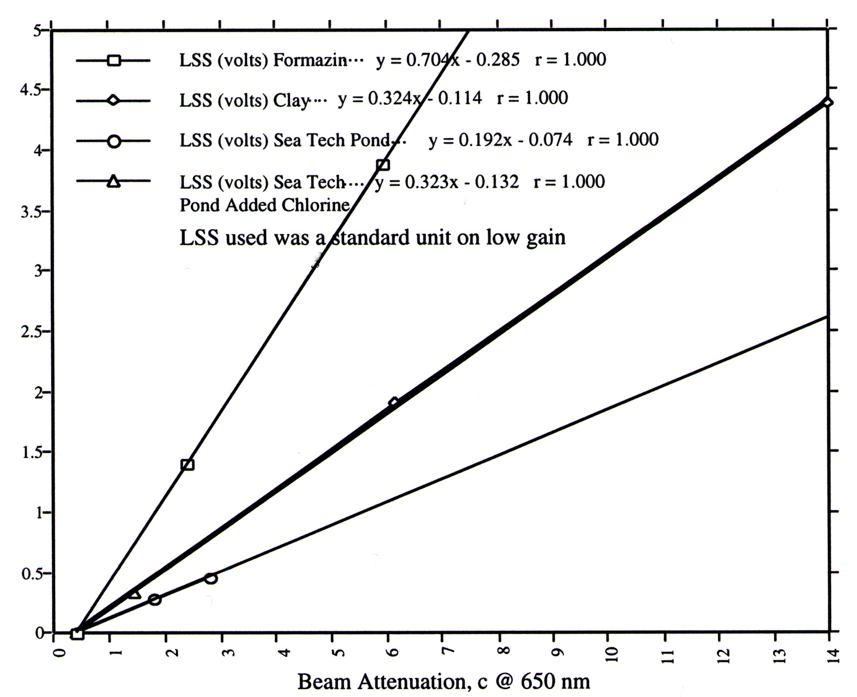

Figure 5. LSS calibration

5.1 Optical Measurements of Suspended Particles in Water
A good correlation exists between any of the optical properties and suspended particulate concentration in water given that the nature of the particles remains constant. In most cases the nature of the particles does remain relatively constant in a given area and because of this optical instruments measuring the optical properties of water have been widely used to measure suspended particulate concentrations in water. The data in Figure 6, a profile of the inherent optical properties found in Green Peter Reservoir, shows typical correlations found in nature. Green Peter Reservoir is a fresh water lake near Sweet Home, Oregon. The data
demonstrate that the inherent optical properties correlate well with the exception of beam absorption near the surface where a large amount of chlorophyll-a fluorescence particles are present. Exceptions occur, but in general this data demonstrates that the LSS will measure nearly the same relative profile of suspended particle concentrations in the water column as would be measured with a transmissometer. The beam attenuation coefficient was measured at two wavelengths: 650 nm and 880 nm with Sea Tech 25 cm pathlength transmissometers. The beam absorption coefficient was measured at 880 nm wavelength with a Sea Tech 25 cm pathlength reflective tube absorption meter. Light scattering was measured with an expendable light scattering sensor at a wavelength of 880 nm. Temperature, depth and chlorophyll-a fluorescence were also measured using Sea Tech Instruments.

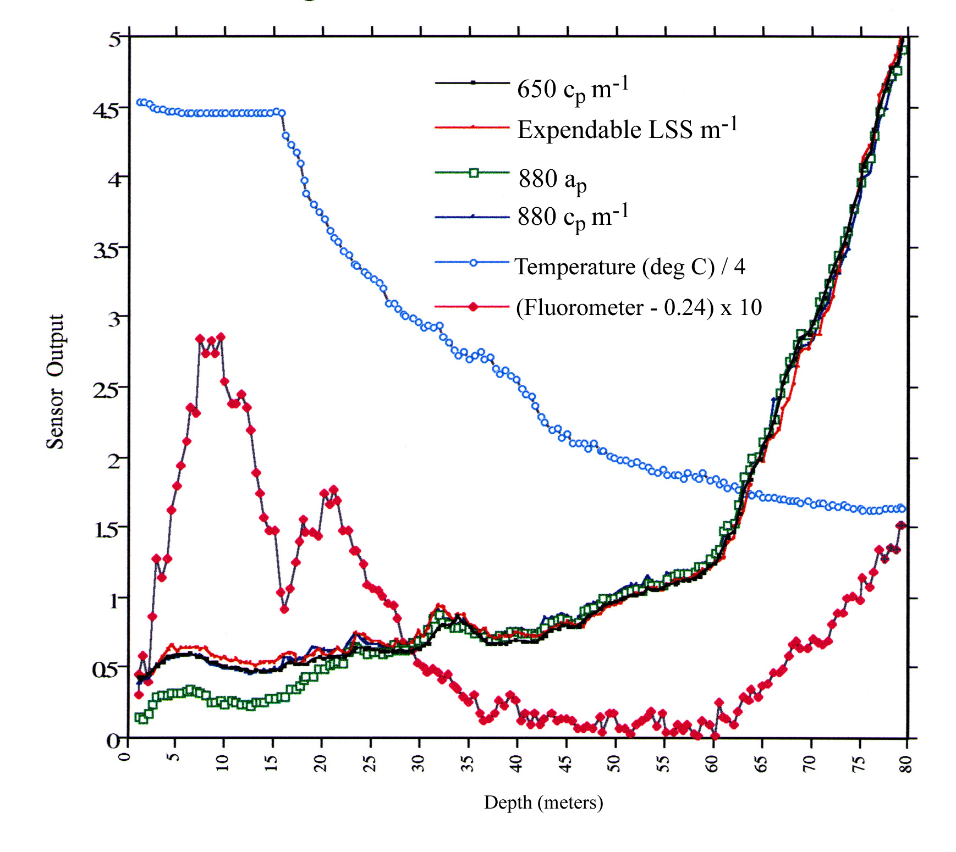
Figure 6. Green Peter reservoir profile

5.2 Calibration Stability
Once calibrated, the calibration stability of the LSS in air can be monitored as shown in Figure 6. This test can be done in the laboratory or the field for both high and low gain.

Select low gain and place the gray side of an 8 x 10 inch Kodak gray card perpendicular to the face of the LSS at the distance “R” where the LSS output is nearly full scale. Record the LSS output voltage. Keeping the same distance “R,” set the gain to high and place the gray side towards the face of the LSS. Record the LSS output voltage.

Note
- Standard (1x) units use gray paper for this test.
- 3x units use black paper.
- Units with other sensitivity settings use white paper.

Zero can be measured by blocking the light receiver with black tape. The distance “R” and LSS output voltages should be recorded and then used to test stability of the LSS as a function of time. Another approach is to record the distance “R” from any stable reflector to the face of the LSS at which full scale, 5 VDC is obtained.

Ideally the distance “R” will be constant with time. The sensor output has nearly a 1/R² response so with any change in the distance, “R” can be converted to a change in sensor calibration. Performing this test at regular intervals allows the user to easily evaluate the LSS sensor calibration stability as a function of time. Testing the LSS in this way also permits the user to determine if the LSS is operating properly. This test should be performed in an environment where ambient lighting and scattered light are relatively low to avoid measurement errors.

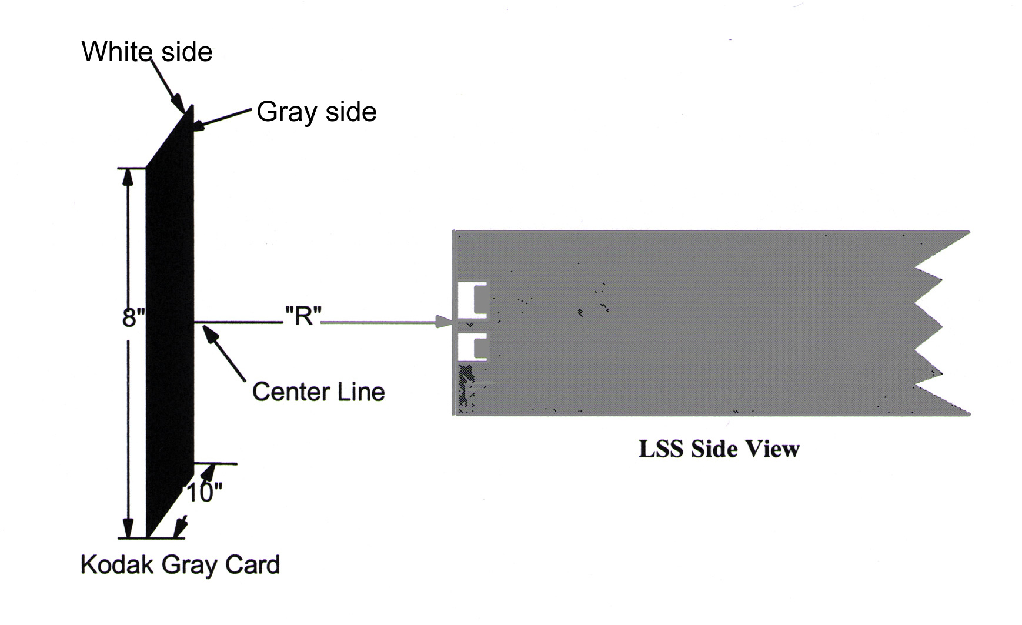
Figure 7. LSS Calibration Stability Test

Light Scattering Sensor

User’s Guide

WET Labs, Inc.
620 Applegate Street
Philomath, OR 97370
Tel: 541-929-5650
fax: 541-929-5277
email: wetlabs@wetlabs.com
www.wetlabs.com

Revision History
Revision | Date | Revision Description | Originator
A | 10/14/99 | Begin revision tracking | H. Van Zee
B | 05/01/01 | Update document (DCR 101) | M. Avery, J. Kitchen
C | 11/26/02 | Add response time to specifications (DCR 256) | D. Hankins

