Observations of pigment and particle distributions in the Western North Atlantic from an autonomous float and satellite ocean color.

E. Boss, D. Swift, L. Taylor, P. Brickley, R. Zaneveld, S. Riser, M.J. Perry and P. Strutton.

Emmanuel Boss, Lisa Taylor, and Peter Brickley
School of Marine Sciences, University of Maine, Orono, Maine 04469

Dana Swift and Steve Riser
School of Oceanography, University of Washington, Seattle, Washington 98195-7940

J. Ronald V. Zaneveld
WET Labs, Inc., P.O. Box 518, 620 Applegate Street, Philomath, Oregon 97370

Mary Jane Perry
Ira C. Darling Marine Center and School of Marine Sciences, University of Maine, Walpole, Maine 04573

Peter Strutton
College of Atmospheric and Oceanic Sciences, Oregon State University, Corvallis, Oregon
97331.

Acknowledgments
This work has been made possible with funding from the Ocean Biology and Biogeochemistry Program of the National Aeronautics and Space Administration (NASA) under grant number NAG5-12473. Discussions with Drs. F. Chai and M. Behrenfeld are gratefully acknowledged.

Abstract
Profiling floats equipped with optical sensors can extend satellite ocean color data to depth as well as provide data during periods and at areas that suffer from cloud cover. Here we demonstrate this ability with a profiling float that obtained continuous high quality optical data for a period of three years without noticeable sensor drift. Good agreement was found with corresponding satellite ocean color. The relationship between chlorophyll and particulate backscattering derived from the float measurements are found to be consistent with previously published data. Upper ocean biogeochemical dynamics are evidenced in the float measurements displaying strong seasonal patterns associated with phytoplankton blooms as well as increase in pigmentation per particle at low light. However, unlike observations at low latitudes, surface optical variables are found to have shorter de-correlation time scales than physical variables suggesting that biogeochemical processes control much of the variability observed.
The float spent 2.25yrs in the Sub-polar North Atlantic between Newfoundland and Greenland before crossing the North Atlantic Current (NAC) to warmer waters. An unusual eddy was sampled following the crossing of the NAC for a three months period. This anti-cyclonic feature contained elevated particulate material from surface to 1000db depth, the only such event in the floats’ record. The eddy was associated with a weakly elevated pigment and backscattering at the surface but its depth integrated backscattering is similar to that during spring blooms. Such eddies, if frequent, are likely to have an important contribution to the delivery of particles to depth, but have seldom been observed.

Introduction

Upper ocean processes have long been known to regulate the vertical distribution of phytoplankton, the dynamics of blooms and primary production (e.g. Riley et al. 1949; Sverdrup 1953; Denman and Gargett 1983; Smetacek and Passow 1990), through their influence on nutrients and light availability to phytoplankton. Unfortunately, measuring primary production (PP) over the appropriate temporal and spatial scales relevant to study the ocean’s role in global elemental cycling and climate is not practical from shipboard observations and therefore efforts have been directed to estimate primary production from remotely observed ocean color.
At this time, however, remotely sensed ocean color cannot alone provide highly accurate phytoplankton standing stocks and PP estimates in the upper ocean since: 1. no consensus exists regarding the appropriate algorithms to obtain PP and their uncertainties, 2. ocean color provides only surface observations requiring assumptions to estimate the subsurface distribution, 3. ocean color chronically under samples cloudy regions, and 4. the atmosphere provides nearly 95% of the signal retrieved by the satellite requiring very accurate atmospheric correction schemes. Since any bias in estimated PP and algal standing stocks directly affects oceanic carbon budgets and fluxes, reducing uncertainties in ocean-color based algorithms will directly improve the latter.
Profiling floats measuring physical parameters such as temperature and salinity have been in operation since the late 1990s and are part of an international observation network (ARGO, e.g. Gould et al. 2004). However, very few profiling floats have been fitted with sensors that monitor the ocean’s biogeochemistry. Recent effort has been undertaken to push for the addition of oxygen sensors to the ARGO floats (Kortzinger et al. 2006). The float described in this paper was equipped with optical sensors capable of providing estimates of the standing stock of particles and phytoplankton chlorophyll a pigment.
Optical properties such as the diffuse attenuation coefficient and beam attenuation have been previously measured with profiling floats (Mitchell et al. 2000; Bishop et al. 2002 & 2004) investigating the dynamics of phytoplankton and particulate organic materials in the upper ocean for periods of up to eighteen months (Bishop et al., 2004). In particular, Bishop et al., 2002, used dusk to dawn changes in beam attenuation to estimate growth-rates of phytoplankton in the upper ocean and related the latter to dust deposition events in the North Pacific.
Here we showcase the use of profiling floats for routine observations of hydrographical and optical properties in the upper ocean and their link to ocean color measurement, as would be possible if such sensors were incorporated to an ARGO-like program. In addition to measuring relevant algal and particulate carbon parameters throughout the year, the float provides measurements in cloudy conditions that could be used to interpolate missing remotely sensed data. The float also provides the distribution of biogeochemical parameters as a function of depth. Together with physical data (both collected by the float and remotely observed) some links between upper ocean dynamics and its biogeochemistry are studied (see also Bishop et al., 2002, 2004, and Uz, 2006, for additional examples and discussion).

Material and methods

A Webb Research Corp. APEX float was fitted with a Sea-Bird Electronics SBE41 CTD and a single prototype flat-faced digital WET Labs hockey-puck sized sensor package that includes two sensor, one measuring side scattering at 880nm (WET Labs’ LSS, e.g. Baker et al. 2001), and the other measuring chlorophyll a fluorescence (470nm excitation, 680nm emission, analogous to the commercially available WET Labs’ ECO fluorometer). The LSS was chosen as it was deemed the most sensitive single-faced scattering sensor available at the time and given its ability to provide estimates of mass concentration of particles in the deep ocean in similar accuracy as that possible with a beam-transmissometers (Baker et al., 2001). Chlorophyll fluorescence provides a proxy of standing stocks of phytoplankton biomass (Cullen, 1982, see discussion below), while scattering provides a proxy for total particulate mass and particulate organic carbon (Baker et al., 2001, Stramski et al., 2007).
The sensor was mounted near the bottom of the float facing approximately 45 degrees outwards from the downward direction to avoid sedimentation of particles on its face and reflections from the float. An oxygen sensor was also deployed on the float but failed within the first six months of launch; hence, data are not reported. Sensors were integrated into the float using a SeaBird Corp. Apf9a controller. The float and sensors were tested for pressure endurance in a pressure tank simulating 50 dive cycles to 1200db recording data throughout the test to evaluate possible effects of pressure on the sensors performance.
The chlorophyll fluorescence sensor was calibrated by the manufacturer with spinach tea, with a diatom culture at the University of Maine, compared to a co-deployed mooring sensor in the field, and finally vicariously calibrated against NASA’s MODIS chlorophyll product. The calibration provides two parameters: a dark signal measured in the absence of fluorescence a slope parameter. The dark signal was established (following the manufacturer’s recommendation) by covering the detector with black tape and immersing the instrument in water while recording the output signal. We have conducted this procedure while simulating dives in a pressure tank and found the dark counts to vary randomly mostly between 24 and 28 counts (with , in some simulated dives, values as low as 19 and as high as 31). The manufacturer suggested dark count was 28 and the minimal value we measured in the field was 23 counts. Given this variability we chose a dark count of 25 for the calculations presented here (and propagated an uncertainty of 6 counts in the estimate of uncertainties below).
The slope (relating measured fluoresced intensity minus the dark signal (in counts) and chlorophyll concentration (in mg m⁻³) is inherently more variable; chlorophyll fluorescence, while a very useful proxy of chlorophyll concentration (given the large dynamic range in the latter) is not a very accurate measure of this concentration (Cullen, 1982, ACT report, 2005) due to variability in the chlorophyll normalized absorption (a function of size and accessory pigments) and fluorescence quantum yield (a function of species, nutritional status, and light history). In particular, the 470nm excitation band associated with our particular sensor is not at the peak of chlorophyll absorption but that of accessory pigments passing the energy to the chlorophyll (Perry et al., this issue), further increasing the potential for difference between laboratory calibration and field estimates. Calibration of a similar fluorescence sensor with a marine diatom species and a marine cyanobacteria resulted in sloped that differed by a factor of 7 (L. Karp-Boss unpublished, see also, Schubert et al., 1989). Indeed, the manufacturer regression slope (9.2⋅10⁻³ mg chl m⁻³ count⁻¹) was different from a calibration with a diatom culture at UMaine (10.8⋅10⁻³ mg chl m⁻³ count⁻¹). Vicarious calibration against sensors on a mooring deployed at the same time as the float and calibrated with chlorophyll extracted from local waters resulted in a significantly lower slope (3.9⋅10⁻³ mg chl m⁻³ count⁻¹) while regression with NASA’s MODIS chlorophyll product (see below) resulted in an even smaller slope (2⋅10⁻³ mg chl m⁻³ count⁻¹). We elected to use the last slope in the data presented here but suggest that these values may be off by a factor of 3 with a minimal absolute uncertainty of +/-0.03 mg chl m⁻³ (NASA report their product to have an average global uncertainty of 30%, see also discussion in Perry et al., this issue).
The light scattering sensor (LSS) was calibrated by the manufacturer with both a turbidity standard (formazine) as well as calibration beads (Duke scientific) at the same time as taking measurements with a spectral beam transmissometer (WET Labs ac9). This sensor was designed to provide a robust estimate of mass concentration of particles (turbidity) and does not have a well defined sampling volume and well defined scattering angle but rather collects light scattered from all angles with maximal response to side scattered photons (Baker et al., 2001).
The calibration provides two parameters: a dark signal measured in the absence of a scattering substance and a slope parameter that relates the counts measured by the instrument (minus the dark counts) and a measure of the concentration of the calibration standard (be it nephlometric turbidity units, NTU, or m⁻¹ when calibrated with a beam attenuation meter or a backscattering sensor, NB: while one can calibrate two optical sensors measuring different scattering angles against a standard they are likely not to agree on field samples as the size and composition of the underlying particles are different, e.g. Gibbs, 1974).
The dark counts were estimated by the manufacturer to be 41.8 while in the pressure tests they varied between 50-54. The lowest value measured in the field was 59 counts. Since the pressure tests were done just prior to deployment we elected to use 51.8counts as the dark count for the calculations presented here (and propagated an uncertainty of 10 counts in the estimate of uncertainties below).
The calibration of the slope in comparison to a beam transmissometer at 650nm differed by a factor of 3 between the Formazin (1.30⋅10⁻⁴ m⁻¹ counts⁻¹) and calibration beads (3.21⋅10⁻⁴ m⁻¹ counts⁻¹). Slope derived from a vicarious calibration against two near-surface bead calibrated 440nm backascattering sensors (providing an estimate of b_{bp}(440)) on a mooring deployed at the same time as the float (1.32⋅10⁻⁵ m⁻¹ counts⁻¹) differed by less than 20% from a regression with inversion of satellite measured ocean color (1.59⋅10⁻⁵ m⁻¹ counts⁻¹, see below detailed of the ocean color processing). We elected to use the last slope in the data presented here. Theoretical considerations (Mie calculation using an acceptable analytical phase function (Fourier-Forand, e.g. Fournier and Jonasz, 1999), indices of refraction, n=1.05-1.15, and particulate size distribution, with differential power-law slope varying from 3.5-4.5, e.g. Stramski and Kiefer, 1991) suggest that the ratio of backscattering at 440nm to the scattering measured by LSS at 880nm varies from 0.2 to 0.56. Thus we estimate the uncertainties in the backscattering coefficients reported here to be on the order of a factor of two with an absolute uncertainty in the backscattering coefficient at 440nm of 3⋅10⁻⁴ m⁻¹ (taking into account both uncertainties in the dark values and in the conversion of LSS measurements to backscattering). Baker et al., 2001, have derived a regression between LSS determine turbidity and suspended matter (mg l⁻¹), which is accurate to within 5%. Using the manufacturer turbidity calibration translated in terms of backscattering, suspended mass (in units of mg l⁻¹) is approximately 20b_{bp}(440). Applying this calibration to the deep clear water values (b_{bp}(440)~2⋅10⁻⁴ m⁻¹, see below) provides an estimate of suspended mass of 0.004mg l⁻¹ that is consistent with a previous report of 0.0045mg l⁻¹ for clear deep North Atlantic waters (Jacob and Ewing, 1968).
The float was deployed at 51.84N 48.43W on 12 June 2004 (Fig. 1). The mission was designed such that the float collected data on its upward trajectory from 1000db to the surface every five days, collecting data at 50 depths during each profile with closer spacing between sampling depths close to the surface and sparser spacing at depth (Approximate depths, with middle value in a triplet denoting the depth interval: 7, 15:5:35, 40:10:300, 325:25:400, 450:50:1000db). In addition, optical measurements were taken at the surface as float was broadcasting data to the ARGOS satellite. The float surfaced close to midnight (local time at the location of its launch) to ensure that chlorophyll a fluorescence measurements were not biased by non-photochemical quenching (e.g. Luftus and Seliger, 1975); as the sun rose, we often observed reductions in fluorescence as function of time. A similar effect has often been observed with fluorometers deployed on other autonomous vehicles such as gliders (Perry et al., this issue). The float subsequently spent approximately 10 hours at the surface, sending data to the ARGOS satellite (using an algorithm that insured that 95% of the data would be transferred) and continuing to collect optical surface data before returning to its parking depth at 1000db. Throughout the float mission it drifted approximately 17° westward from its launch position, changing its rise relative to the local midnight by less than two hours.
Ocean color remote sensing products were obtained from http://oceancolor.gsfc.nasa.gov/PRODUCTS/. Here we used NASA’s standard chlorophyll product for Moderate Resolution Imaging Spectroradiometer (MODIS) and computed the particulate backscattering coefficient at 440nm (b_{bp}(440)) by performing an inversion on the normalized water leaving radiances with the algorithm outlined in Maritorena et al. (2002). Level 2 data were processed as follows: all satellite passes within a six-hour period, which amount to all data collected within a daylight period, were averaged into a single scene. Subsequently the data were median-averaged over the non-masked data pixel found within 7.5km of the float’s most recent location. For the vicarious calibration described above, the ocean-color data were interpolated to the time of the float surfacing (n=202 for b_{bp} and n=208 for chlorophyll). The 7.5km scale was based on a spatial decorrelation analysis (not shown) and agrees with the local baroclinic radius of deformation (e.g. Smith et al. 2000). We tested for contamination of pixels adjacent to clouds by applying a dilation operator; cloud masked regions are enlarged by a binary dilation operation with a disk shaped kernel (two pixel radius) to remove cloud edge effects (Gonzales and Woods, 1992). This operation reduced the number of available remotely sensed spectra obtained for 12 June 2004 to 1 May 2007 from 233 to 150 without changing significantly either the correlation coefficient or the calibration slope between in-situ data and those inverted from satellite. We thus elected not to use the dilation procedure.
Sea surface height anomaly data with ¼° degree resolution were obtained from the Colorado Center for Astrodynamics Research at the University of Colorado, Boulder. Data were processed as in Leben et al. (2002).
Results

Sensor stability
Float 0005 accomplished 221 profiles of the upper 1000m of the Western North Atlantic Ocean, once every five days since its launch on June 12, 2004 through the 22nd of June 2007. The float spent most of its mission in the Subpolar Gyre before crossing the North Atlantic Current (NAC) in September 2006 into the warmer waters to its south (Fig. 1). After crossing the NAC, the float spent approximately 3 months within an anti-cyclonic eddy with highly elevated backscattering values (see below).
Data from 950m and below suggest the float sensors were stable over the three-year mission (Fig. 2). Except for rare spikes in the back-scattering coefficient, and the higher values associated with passage through an eddy, the deep values are approximately constant
(b_{bp}(440)~0.0015m⁻¹). Although the remotely sensed data were used to derive the (single) slope coefficient to convert digital to calibrated data, the consistent correlation between estimated surface values of chlorophyll and backscattering with those obtained from remote over three years supports our hypothesis of little drift in the optical sensors sensing (Fig. 3, correlation coefficient R=0.88 for chlorophyll and 0.90 for backscattering, independent of the slope value chosen).
The relationship between particulate backscattering and chlorophyll estimated from the float’s measurements are also consistent with relationships derived from in-situ measurements in the Southern Ocean (Fig. 4, Reynolds et al., 2001), the South Pacific by (Fig. 4, Huot et al., 2007) and derived from ocean color (Fig. 4, Behrenfeld et al., 2005).

Upper ocean dynamics
Phytoplankton surface distributions are spatially patchy (O(1 deformation radius here ~10km)) and have the potential to be highly variable temporally due to growth rates (being on the order of a day), grazing and meso-scale dynamics. Thus one may expect data to be highly uncorrelated between subsequent profiles. Contrary to this expectation, however, we find the shortest de-correlation time scale (that of chlorophyll) to have an e-folding time of nearly two weeks (Fig. 5). The near-surface optical properties (and thus biogeochemistry) have shorter de-correlation time scales than the physical properties (Fig. 5).
The float spent a little more than two years in the Subpolar Western North Atlantic (Fig. 1). The annual cycle dominates the variability with warming between February and late August and subsequent cooling (Figs. 3, 6). The near-surface chlorophyll and backscattering coefficients in the upper ocean are always higher than at depth and exhibit a rapid rise in the spring and a slower decrease in the fall and winter. The chlorophyll and backscattering coefficients are well correlated (R>0.86) in the upper 300m consistent with backscattering being dominated by phytoplankton and particles that covary with phytoplankton (Fig. 4). Note, however, that significant variation in chl/b_{bp} ratio are observed (Fig. 6); below the mixed layer in the summer, a significant increase in chlorophyll to b_{bp} ratio is observed, consistent with photo-acclimation of cells to low light and/or availability of nutrients to them (Fig. 6). This ratio also increases near the surface in the winter, possibly due to increase in pigmentation associated with short day light and deeper mixing. At greater depths no significant signal in pigments is observed while the seasonal modulation in backscattering is observed all the way to the deepest depth bin (750-1050db) though with an amplitude that is two orders of magnitude smaller than at the surface and a maximum which is shifted later in the year relative to the surface’s particle concentration maximum (Fig. 7).
Effects of clouds
To assess the usefulness of the float’s ability to sample under clouds we compared the temporal coverage available by the float (5-6 surfacing per month) to that of the satellite (Fig. 8) within the 7.5km radius around the float’s latest position. While in summer months we obtained denser remote sensing data, during the winter the float data density was superior.
To determine whether superior data density by the float in the winter could translate to better monthly mean data, we computed the ratio of the monthly standard deviation to the monthly mean (the coefficient of variation, Fig. 8) for the float chlorophyll data. During cloudy periods (when the number of satellite samples is low) the coefficient of variation in optical properties is usually also low, indicating little change in upper ocean chlorophyll. Sunny periods, associated with many remote observations, are usually also associated with a large coefficient of variation in upper ocean chlorophyll. This variance, however, is often captured by the more frequent satellite ocean color measurements.

The eddy event
An unusual eddy was sampled by the float in the fall of 2006 following the crossing of the Gulf Stream; this eddy was quasi-stationary from September to mid-November (not shown), had a small expression in surface ocean color data (relative to measurements before and after its encounter, Fig. 3) and was observed well in altimetry data (Fig. 9). While encircling the eddy the float recorded the only occasion of significant elevated scattering above background at depths below 950db (Fig. 2). Depth-integrated chlorophyll values show little signal associated with the eddy, however integrated b_{bp} values show a signal which is comparable in magnitude to that observed during the spring bloom (Fig. 10).
Discussion and conclusions

We have demonstrated the ability to measure optical variables for a period of three years by a profiling float. The data quality was maintained with no fouling observed. This is possibly attributable to the mission profile which includes a large fraction of time in the deep dark and cold ocean and a relatively short stay at the surface (about ten hours every five days and mostly at night, see also Bishop, 2002).
Good temporal correlation with remotely sensed observations showcases the potential to use similar sampling platforms for validation and/or interpolation of ocean color data. In addition, as demonstrated here, it allows for testing of potential biases in monthly mean values due to cloud conditions. Here we find that within the Sub-polar Gyre the periods of low satellite coverage (i.e., winter) are correlated with low variability in chlorophyll suggesting that in that at high latitudes in winter clouds do not significantly bias remotely estimated monthly means. This may be explained with the winter period being associated with low temperature and lower averaged mixed layer light-levels, both of which are likely to decrease phytoplankton growth rates.
The vicarious calibration approach performed here provides a consistent chlorophyll-b_{bp} relationship (Fig. 4). It is, however, advisable to use a sensor that is better constrained in the parameter it measures (e.g. backscattering or attenuation, both good proxies for particulate organic carbon, e.g. Bishop, 1999, Stramski et al., 2007) than the scattering sensor used here. If possible, it is also advisable to calibrate chlorophyll fluorometers with extracted chlorophyll from local phytoplankton populations as often as possible or possibly use sensors providing proxies of chlorophyll absorption. Note that it is often the case that beam transmissomters are calibrated against the clearest deep waters in a deep cast (e.g. Stramski et al., 2007 and references therein). If such a procedure were to be used here, the particle signal increase associated with the eddy would have been greatly reduced if not completely erased.
Autocorrelation analysis of the whole data set reveals chlorophyll to have a shorter de-correlation time scale than backscattering. This is likely due to the ability of phytoplankton to rapidly (within a generation time scale) alter their intercellular chlorophyll concentration in response to changes in light and nutrients. It may also suggest that backscattering is not responding only to material that covaries with phytoplankton.
The de-correlation time scales observed by the float are significantly longer than the O(2days) de-correlation time scales calculated by Strutton and Chavez (2003) for chlorophyll obtained from ocean color data from the equatorial Pacific and the O(4days) de-correlation time scale calculated for in-situ chlorophyll from drifters in the California current by Abbott and Letelier (1998). This may seem surprising given the shorter deformation radius in the North Atlantic. The reason for the longer de-correlation time scale observed with the float is the significantly larger seasonal signal in the North Atlantic, which dominates the observed variability as well as possibly the reduced growth rates by phytoplankton in the cold water of the Western North Atlantic (Eppley, 1972). Denman and Abbott (1994) and Abbott and Letelier (1998) observed equal de-correlation time scales for temperature and chlorophyll while here we observe shorter de-correlation time scales for all the optical variables compared to the hydrographic variables. Strutton and Chavez (2003) interpret covariation in de-correlation time scales as being a sign of causality. Under that interpretation, our observation suggests that phytoplankton in the Western North Atlantic is significantly modulated by other processes than those responsible for variability in the upper ocean’s hydrography.
A particle rich eddy was sampled in the late fall of 2006 which had little surface expression in ocean color. Its particle load is observed coherently through the 1000db water column suggesting it may be responsible for a large flux of particles to depth. This event is reminiscent of observations at the Bermuda Atlantic Time Series (BATS, Conte et al. 2003) where during some winters large flux of biogenic materials were collected in 3000db sediment traps associated with an eddy feature but with little surface expression in chlorophyll. Currently we do not have a mechanism to explain the processes that formed or concentrated the material within the eddy; settling velocities of micron size particle such as coccoliths cannot explain the temporal coherence in signal between near surface measurements and those at 1000db (B. Balch, 2007, personal communication). Additionally, no anomalous atmospheric transmission values, possibly associated with a dust deposition event, occurred during that time.
Eddies such as that sampled by the float and those observed at BATS could be very important (even dominant) in the global biogeochemical inventory of carbon and its flux to depth. However, currently we cannot account for such contributions due to our inability to sample the subsurface ocean from space and the limited space and time scales observed using ship board observations or single point moorings which cannot capture many realizations of such eddies.
It is our hope that the success and results demonstrated here and in previous studies (e.g. Bishop et al., 2002, 2004) will encourage the addition of biogeochemical sensors to the existing and planned fleet of autonomous platforms in the world’s ocean. Such a fleet will provide necessary inputs and constraints for ocean scale biogeochemical and ecosystem models which are necessary to increase our understanding of the role the oceans are playing in biogeochemical cycling in general and in recent climate processes in particular.
If a fleet of biogeochemical profiling floats were to operate throughout the world’s ocean, the contribution of the mesoscale band to important biogeochemical fluxes could be constrained. Such a fleet exists for the measurements of hydrographical properties. A coordinated effort by the oceanographic community, such as the current effort to include oxygen measurements as part of the ARGO program, could make it a reality.
In addition, ecosystem and biogeochemical ocean models are starting to use optical variables to better model the underwater light field (e.g. for photosynthesis and photo-oxidation) and constrain biogeochemical variables (e.g. Fujii et al., 2007). Data such as that collected by the float discussed here could provide these models with much needed ground truth resulting in increased skill.
Newer communication technologies such as satellite cell phones (e.g. iridium) can significantly improve future float missions since they allow for significantly shorter stays at the surface (to less than ten minutes per profile), two-way communication (allowing for adaptive sampling), and provide for higher vertical resolution of data for the same amount of power.

References
ACT, 2005. Workshop proceeding on ‘Applications of in situ fluorometers in nearshore waters. Alliance of coastal technologies indexing No. ACT-05-03.
Abbott, M. R. and R. M. Letelier. 1998. Decorrelation scales of chlorophyll as observed from bio-optical drifters in the California Current. Deep-Sea Res. II, 45, 1639-1667.
Baker, E. D., A. Tenant, R. A. Feely, G. T. Lebon, and S. L. Waker. 2001. Field and laboratory studies on the effect of particle size and composition on optical backscattering measurements in hydrothermal plumes. Deep-Sea Res. I 48: 593–604.
Bishop, J.K.B., 1999. Transmissometer Measurement of POC. Deep-Sea Res. I. 46: 353-369.
Bishop, J.K.B., R.E. Davis, and J.T. Sherman. 2002. Robotic observations of dust storm enhancement of carbon biomass in the North Pacific. Science 298: 817-821.
Bishop, J.K.B., T.J. Wood, R.E. Davis, and J.T. Sherman. 2004. Robotic observations of enhanced carbon biomass and export at 55S. Science 304: 417-420.
Cloern, J. E., C. Genz, and L. Vidergar-Lucas. 1995. An empirical model of phytoplankton chlorophyll: carbon ratio - the conversion factor between productivity and growth rate. Limnol. Oceanogr. 40: 1313–1321.
Conte, M.H., T.D. Dickey, J.C. Weber, R. Johnson, and A. Knap. 2003. Transient physical forcing of pulsed export of bioreactive material to the deep Sargasso Sea. Deep-Sea Res. I 50: 1157-1187.

Cullen, J. J. (1982). The deep chlorophyll maximum: comparing vertical profiles of chlorophyll a. Can. J. Fish. Aquat. Sci. 39: 791-803.
Denman, K. L., and A. E. Gargett. 1983. Time and space scales of vertical mixing and advection of phytoplankton in the upper ocean. Limnol. Oceanogr. 28: 801-815.
Denman, K. L. and M. R. Abbott. 1994. Time scales of pattern evolution from cross-spectrum analysis of advanced very high resolution radiometer and coastal zone color scanner. J. Geophys. Res. 99: 7433-7442.
Eppley, R. W. 1972. Temperature and phytoplankton growth in the sea. Fish. Bull. 70: 1063-1085.
Fujii, M., Boss, E., and Chai, F. 2007. The value of adding optics to ecosystem models: a case study, Biogeosciences, 4: 817-835.
Fournier G. and M. Jonasz, 1999. Computer-based underwater imaging analysis, in Airborne and In-water Underwater Imaging, G. Gilbert, ed., Proc. SPIE 3761: 62–77.
Gibbs, R. J. [Ed.]. 1974. Suspended solids inwater. Marine Science Ser. 4. Plenum Press,
New York and London.
Gould, J., et al. 2004. Argo profiling floats bring new era of in situ ocean observations. Eos Trans. AGU 85(19): 185.
Huot, Y., Morel, A., Twardowski, M. S., Stramski, D., and Reynolds, R. A. 2007. Particle optical backscattering along a chlorophyll gradient in the upper layer of the eastern South Pacific Ocean, Biogeosciences Discuss., 4: 4571-4604.
Jacobs, M. B., and M. Ewing. 1968. Suspended particulate matter: concentration in the major oceans. Science 163: 380-383.
Körtzinger, A., S. C. Riser, and N. Gruber. 2006. Oceanic oxygen: the oceanographer's canary bird of climate change. Argo Newsletter Argonautics 7 June 2006: 2-3.
Leben, R. R., G. H. Born, B. R. Engebreth. 2002. Operational altimeter data processing for mesoscale monitoring. Marine Geodesy 25: 3-18.
M. E. Loftus and H. H. Seliger. 1975. Some limitations of the In vivo fluorescence technique. Chesapeake Science 16: 79-92. doi:10.2307/1350685
Maritorena S., D.A. Siegel, and A. Peterson. 2002. Optimization of a semianalytical ocean color model for global-scale applications. Appl. Opt. 41: 2705-2714.
Mitchell, B.G., M. Kahru, and J. Sherman. 2000. Autonomous temperature-irradiance profiler resolves the spring bloom in the Sea of Japan. Proceedings, Ocean Optics XV, Monaco, October 2000.
Perry M. J., B. S. Sackmann, C. C. Eriksen and C. M. Lee., 2008. Seaglider observations of blooms and subsurface chlorophyll maxima off the Washington coast, USA. Limnol. Oceanog. Submitted.
Reynolds, R. A., D. Stramski, and B. G. Mitchell. 2001. A chlorophyll-dependent semianalytical reflectance model derived from field measurements of absorption and backscattering coefficients within the Southern Ocean. J. Geophys. Res. 106: 7125–7138.
Riley, G.A., H. Stommel, and D.F. Bumpus. 1949. Quantitative ecology of the plankton of the Western North Atlantic. Bull. Bingham Oceanogr. Coll. 12(3): 1-169.
Schubert H., U. Schiewer , and E. Tschirner, 1989. Fluorescence characteristics of cyanobacteria (blue-green algae). J. Plankton Res. 11: 353-359.
Smetacek, V., and U. Passow. 1990. Spring bloom initiation and Sverdrup's critical-depth model. Limnol. Oceanogr. 35: 228-234.
Smith, R.D., M.E. Maltrud, F.O. Bryan, and M.W. Hecht. 2000. Numerical simulation of the North Atlantic Ocean at ¹/₁₀°. J. Phys. Oceanogr. 30: 1532–1561.
Spinrad, R.W., and J.R.V. Zaneveld. 1982. An analysis of the optical features of the near-bottom and bottom nepheloid layers in the area of the Scotian Rise. J. Geophys. Res. 87: 9553-9561.
Stramski, D., Kiefer, D.A., 1991. Light scattering by microorganisms in the open ocean. Progress in Oceanography 28: 343-383.
Stramski, D., Reynolds, R. A., Babin, M., Kaczmarek, S., Lewis, M. R., Röttgers, R., Sciandra, A., Stramska, M., Twardowski, M. S., and Claustre, H. 2007. Relationships between the surface concentration of particulate organic carbon and optical properties in the eastern South Pacific and eastern Atlantic Oceans, Biogeosciences Discuss., 4, 3453-3530.
Strutton, P.G. and F.P. Chavez. 2003. Scales of biological-physical coupling in the equatorial Pacific. In L. Seuront and P.G. Strutton [eds.], Handbook of scaling methods in aquatic ecology. CRC Press, Boca Raton, FL.
Sverdrup, H. U. 1953. On conditions for the vernal blooming of phytoplankton. J.
Conseil Exp. Mer. 18: 287.
Uz B. M. 2006. Argo floats complement biological remote sensing. EOS Transactions Vol. 87(32), 313-320.
Figure Legends

Fig. 1. Float trajectory.

Fig. 2. Measurements of temperature, salinity, backscattering at 440nm and chlorophyll at depths deeper than 970m. The two lines denote the crossing of the Gulf Stream (left) and the center of the eddy event (see text).

Fig. 3. Time series of the particulate backscattering coefficient at 440nm and chlorophyll concentration obtained from inverting satellite ocean color and from the float sensor. The float sensor data was converted to chlorophyll concentration and b_{bp}(440) by vicariously calibrating it with the same ocean color data (from which the single slope parameter was obtained, see text).

Fig. 4. Particulate backscattering coefficient at 440nm vs. chlorophyll data acquired by the float at the upper ten meter (black) and the upper 300m of the water column. In addition, four published relationships are overlaid: (1) Huot et al., 2007, (2) Reynolds et al., 2001, Ross, (3) Reynolds et al., 2001, APFZ, and (4) Behrenfeld et al., 2005. Note that a factor of 1.25 was used to multiply relationships providing b_{bp}(550) as a function of chlorophyll to obtain b_{bp}(440) for inclusion in the figure based on assuming a λ⁻¹ spectral functionality for b_{bp}. Values of chlorophyll smaller than 0.04mg m⁻³ are not significantly different from zero, e.g. Fig. 2.

Fig. 5. Lag correlation for near-surface chlorophyll, backscattering, density, salinity and temperature. Temporal averages were removed from all variables prior to computing the lag correlation.

Fig. 6. Evolution of density, log₁₀ backscattering at 440nm, and log₁₀ chlorophyll and the ratio of chlorophyll to backscattering at 440nm as a function of time and depth in the upper 300m. The black line denotes the mixed layer depth based on the depth where the density is 0.125kg m⁻³ higher than near the surface.

Fig. 7. Evolution of chlorophyll, density, backscattering and temperature as a function of time for five depths bins. Lines represent the median of properties values for data in the following depth bins: [0-30db], [75-130db], [185-245db], [315-480db], and [750-1050db]. Each bin contains approximately five sampling depths. The two vertical lines denote the crossing of the Gulf Stream and the center of the period when the float was sampling an eddy.

Fig. 8. Number of data points in each month (circle-float, star-satellite) and coefficient of variation of chlorophyll (based on float, line) as a function of time.

Fig. 9. Float trajectory from 1 September to 31 December 2006 overlaid on a contour of sea surface anomaly (in cm) obtained for 18 October 2006. Note the anti-cyclonic eddy centered at 50N 37W. This feature was quasi-stationary at this location for longer than two months.

Fig. 10. Integrated chlorophyll (thick line, left y-axis) and particulate backscattering (thin line, right y-axis) from the surface to 300db depth.

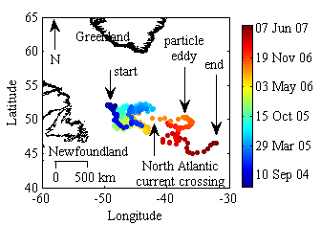
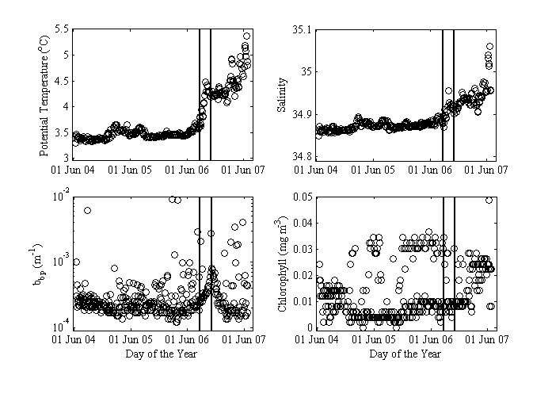

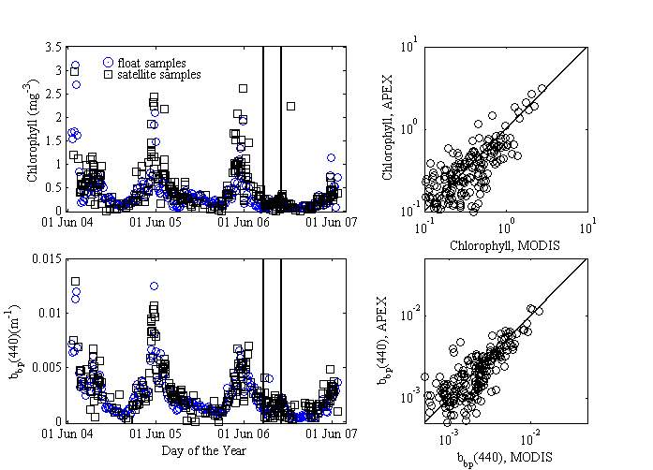

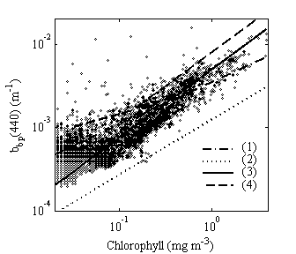

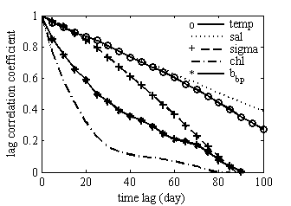
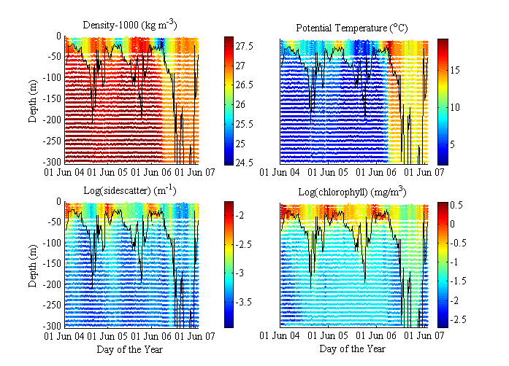

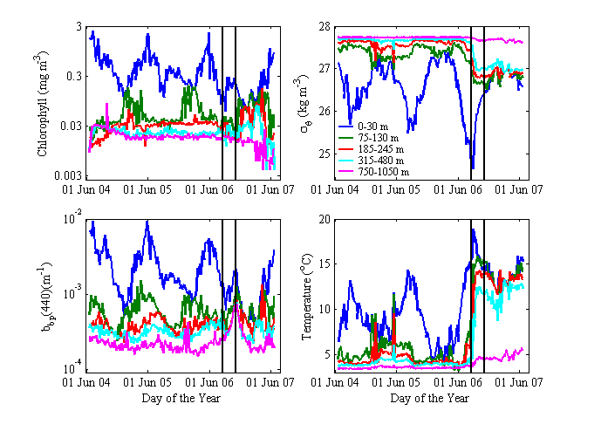

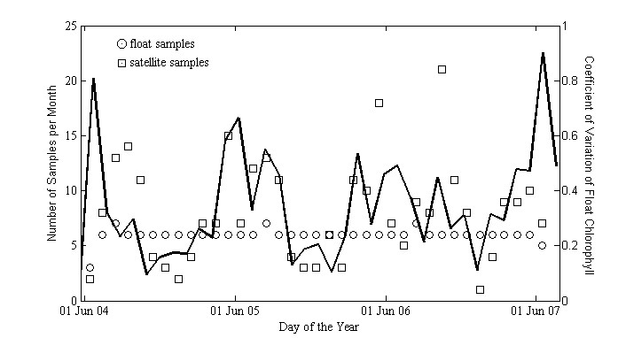
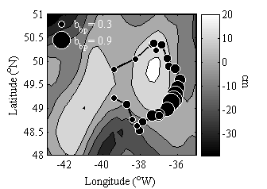

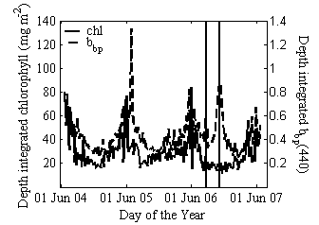

Corresponding author (emmanuel.boss@maine.edu).

